Microservices Identification with HLD --------------------------------------------------------------------

API Endpoints for each Microservice ---------------------------------------------------------------------------------

Success & Failure Scenarios ---------------------------------------------------------------------------------------------

Discovery Server Implementation -------------------------------------------------------------------------------------

Interservice Communication Approach ------------------------------------------------------------------------------

Cross Cutting Concerns ---------------------------------------------------------------------------------------------------

Deployment -----------------------------------------------------------------------------------------------------------------

Technologies & Tools used -----------------------------------------------------------------------------------------------

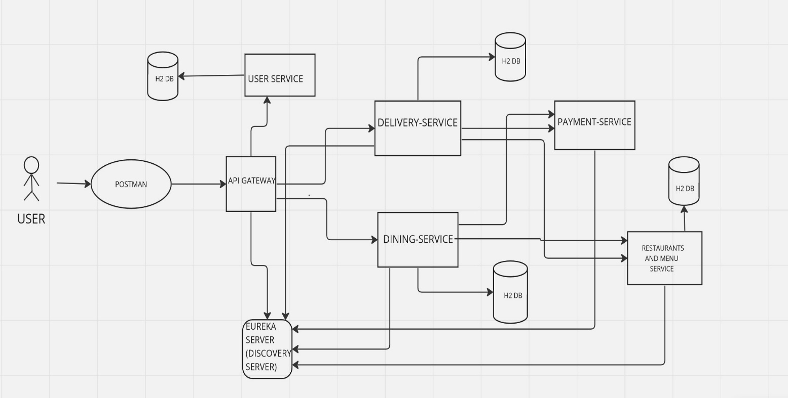

High Level Diagram

Food Portal HLD Explanation:

Given above is the HLD for the food portal, the user interacts with the API’s using Postman. The request from postman is sent to the API Gateway where the requests are routed to the different services according to the request received.

All the services including the API gateway are registered on the Discovery server (i.e., Eureka server, in our case) which helps in the identification of the services so that they can interact with each other.

API gatway interacts with the user service for the authentication of the user and any user has to signup and then login through the user service for accessing the other services else they will receive 401 Unauthorized error.

The API gateway is therefore authenticating the user here along with the load balancing and routing of the requests to the different services.

Services Identified:

1. USER-SERVICE

This service is responsible for :

1. Signing up the user(Register a user).
2. Logging in a user.
3. Authorization(whether the role is user or admin).
4. Validates the request parameters and then proceed with the request.

1. DISCOVERY-SERVER
2. Discovery server registers all the services and displays all the registered service along-with their availability status (whether they are up and running or else).
3. It also allows the services to communicate with each other.

3.API-GATEWAY

This service is responsible for :

* The requests from the end-user are first sent to the gateway and these requests are routed to the services accordingly by the gateway. It ensures the services are not directly exposed to end-user, so we get all the requests in gateway only.
* Only allows two requests to hit directly without token i.e., signup & login.
* User authentication is done in the gateway.
* Also it acts as a load balancer for the requests being routed to the services.
* Validates all the requests and then route to services.
* Provides ease of access for users that they don’t need to hit multiple ports for multiple services.

1. RESTAURANTS AND MENU SERVICE

* This service is responsible for fetching restaurants and their menus.
* Maintains the inventory for the restaurants as well as their menu and the food items in the menu.
* Responsible for fetching details of the restaurants and helps in adding a restaurant.
* Food items/menu can be added for a restaurant.
* Users can search for food menu by restaurant, area code , food item. Also, they can add a restaurant to their favourites list.

1. DELIVERY-SERVICE

* Delivery service is responsible for the delivery functionality.
* Maintains the delivery order details.
* Here,users can add/remove items to the cart,view their cart and place an order.
* This service interacts with RESTAURANT AND MENU SERVICE to fetch the details and place the order.Also,it integrates with the PAYMENT SERVICE for payment for the order or issue a refund.
* User details are sent to the RESTAURANT AND MENU service once the order is placed.Order details are logged in the service.
* Circuit breaker and logging is enabled.
* All the request parameters are validated and then the proceed else an appropriate exception/error response is thrown.

6.DINING-SERVICE

* Dining service is responsible for the food dining functionality.
* Maintains the dining booking details.
* Here,users can book a table for dining in a restaurant for the preffered date and slot.
* This service interacts with RESTAURANT AND MENU SERVICE to fetch the restaurant details and book the dining.
* User details are sent to the RESTAURANT AND MENU service once the booking is completed.Booking details are logged in the service itself.
* Circuit breaker and logging is enabled.
* All the request parameters are validated and then the proceed else an appropriate exception/error response is thrown.

7.PAYMENT-SERVICE

* Payment service is responsible for the accepting of payments for the delivery order and issue refund in case of cancellation using transaction id.
* Validates the request parameters and then the request is proceed else exception thrown. Logging is implemented as well.

Detailed API Explanation:

* Please find below the detailed API explanation for each of the services which includes the method type,their request URLs and the request and response structure.
* Since all the services are registered on the discovery server including the api gateway , all the services are being routed through the API Gateway (i.e. port 9001 ) and without the user login ,other services will throw the “401 Unauthorized “ Code.
* Besides ,once the user logs in, the username will be set automatically for the further requests as we are providing it in the request header as ‘X-Authenticated-User’ in each of the API’s.

1.USER-SERVICE

* SIGNUP

This API is to sign up the new users on the portal.

Method Type: - POST

Request URL: - /user/signup

Request Body: -

{

"username":"user-name",  
 "password":"password"  
 }  
  
 Response:  
   
 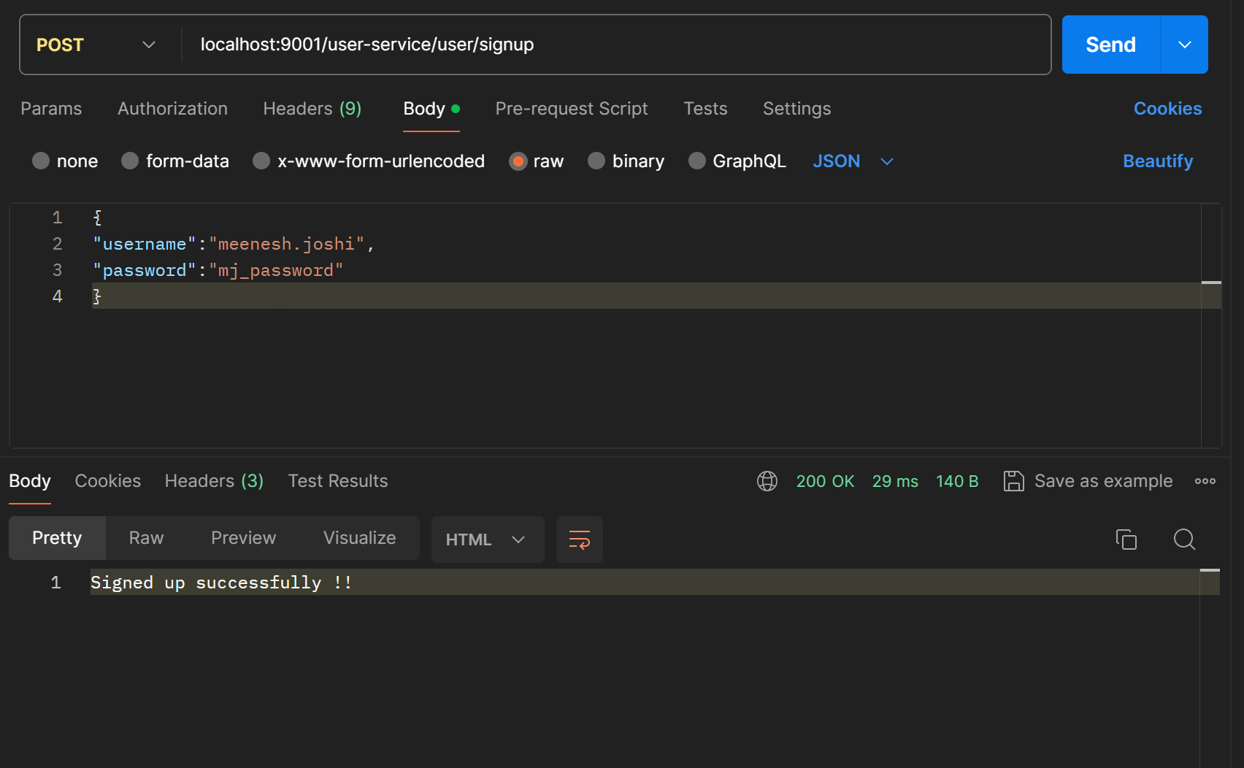

* LOGIN  
    
  This API is used for login by the signup users and generates a token and that token can be used in the further requests for authentication.  
    
  Method Type: - POST

Request URL: - /user/login

Request Body: -

{

"username":"user-name",

"password":"password"

}

Response :  
 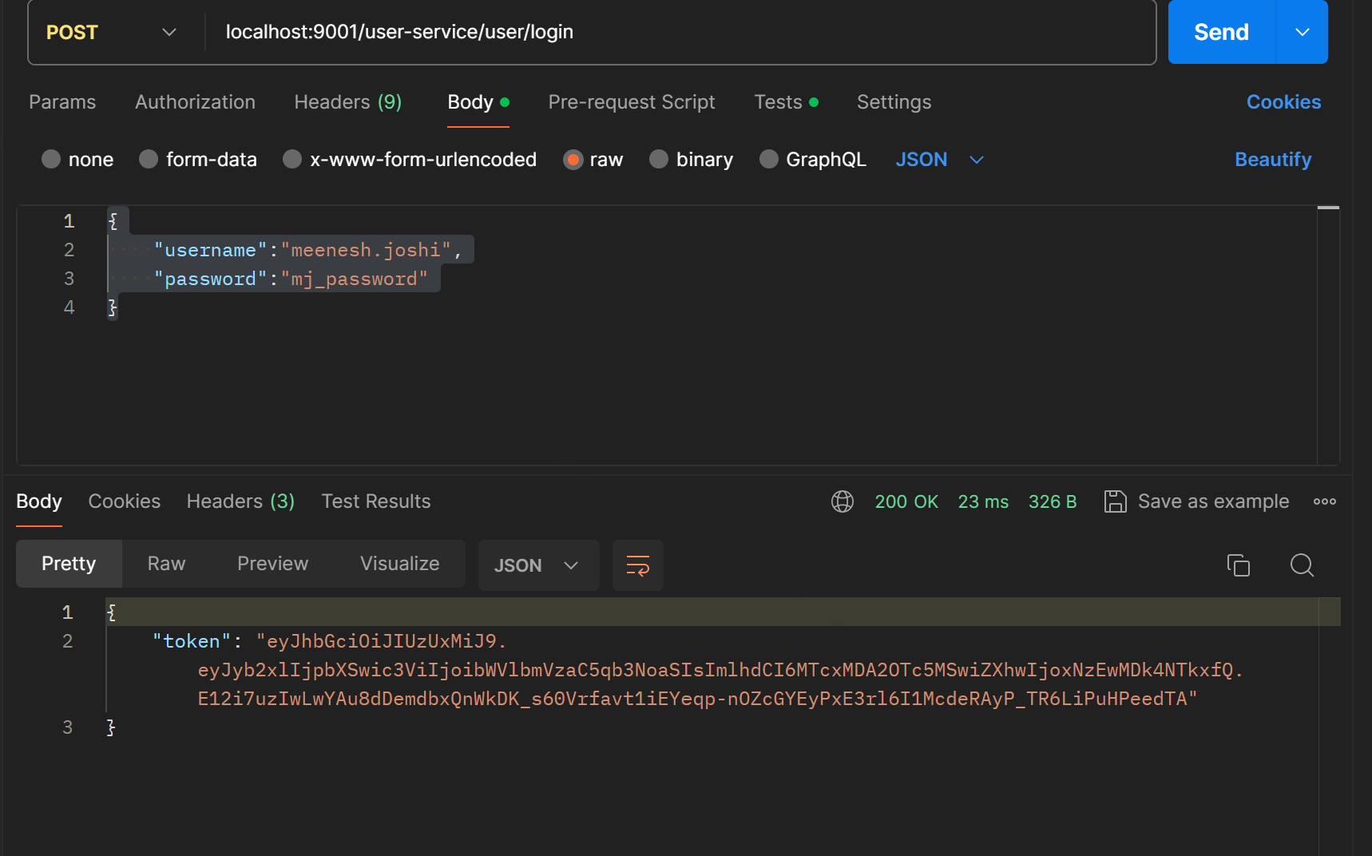

* VERIFY

This API is used to verify the users and their roles whether they are ADMIN or USER with the help of token we got from the previous API.

Method Type: - POST

Request URL: - /user/verify

Request Body: -

{

"username":"user-name",

"password":"password"

}

Response:

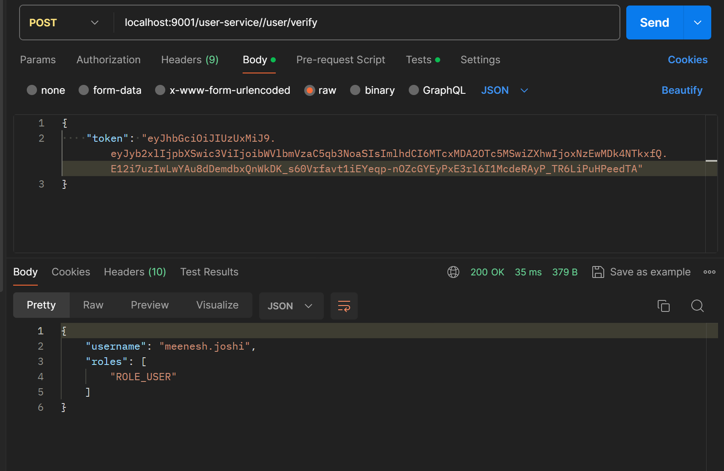

2. RESTAURANTS-AND-MENU-SERVICE

**Get All Restaurants**

* This API is used for searching all the available restaurants in inventory and return all the available restaurants with their address.

Method Type : GET

Request URL: /restaurant/getAllRestaurants

Response:  
  
[

    {

        "restaurantId": "2d0f94a0-ffec-4e2f-9569-5b39b206f707",

        "restaurantName": "Chilli's 360",

        "address": {

            "streetAddress": "987 Willow Avenue",

            "city": "Bangalore",

            "areaCode": "Sector 31",

            "diningCapacity": 5,

            "openTime": "10:00:00",

            "closeTime": "22:00:00"

        }

    },

    {

        "restaurantId": "51293f75-7f44-457c-8bc7-98c94308e197",

        "restaurantName": "Palette Pleasures",

        "address": {

            "streetAddress": "210 Maple Lane",

            "city": "Bangalore",

            "areaCode": "Sector 14",

            "diningCapacity": 4,

            "openTime": "09:00:00",

            "closeTime": "20:00:00"

        }

    },

    {

        "restaurantId": "422f9709-0eb3-41b8-9d0a-169207b66c74",

        "restaurantName": "Spice Paradise",

        "address": {

            "streetAddress": "456 Elm Avenue",

            "city": "Bangalore",

            "areaCode": "Sector 12",

            "diningCapacity": 3,

            "openTime": "10:00:00",

            "closeTime": "21:00:00"

        }

    },

    {

        "restaurantId": "956339a2-d94b-4f20-a7c6-33b6cee775fc",

        "restaurantName": "Spice Paradise",

        "address": {

            "streetAddress": "789 Oak Lane",

            "city": "Bangalore",

            "areaCode": "Sector 31",

            "diningCapacity": 7,

            "openTime": "11:00:00",

            "closeTime": "23:00:00"

        }

    },

    {

        "restaurantId": "5311b6d1-98c7-4d1a-9c7b-ce8feb6a53fc",

        "restaurantName": "Wholesome Delights",

        "address": {

            "streetAddress": "321 Pine Road",

            "city": "Bangalore",

            "areaCode": "Sector 22",

            "diningCapacity": 5,

            "openTime": "10:00:00",

            "closeTime": "21:00:00"

        }

    },

    {

        "restaurantId": "86f7daa1-504d-4c29-a2a8-657d7996f7c4",

        "restaurantName": "Gourmet Oasis",

        "address": {

            "streetAddress": "210 Maple Lane",

            "city": "Bangalore",

            "areaCode": "Sector 14",

            "diningCapacity": 6,

            "openTime": "08:00:00",

            "closeTime": "20:00:00"

        }

    },

    {

        "restaurantId": "539660ef-40b7-4e74-994b-504b8f6eae16",

        "restaurantName": "Mango Bistro",

        "address": {

            "streetAddress": "654 Cedar Street",

            "city": "Bangalore",

            "areaCode": "Sector 22",

            "diningCapacity": 3,

            "openTime": "10:00:00",

            "closeTime": "22:00:00"

        }

    },

    {

        "restaurantId": "86816ab8-59f1-4bac-8334-2233a8edcde4",

        "restaurantName": "Sizzler's Delight",

        "address": {

            "streetAddress": "130 Oak Lane",

            "city": "Bangalore",

            "areaCode": "Sector 14",

            "diningCapacity": 2,

            "openTime": "08:30:00",

            "closeTime": "19:30:00"

        }

    },

    {

        "restaurantId": "65aced99-a469-4280-8596-2f19a33cc331",

        "restaurantName": "Cafe Fusion",

        "address": {

            "streetAddress": "321 Pine Road",

            "city": "Bangalore",

            "areaCode": "Sector 22",

            "diningCapacity": 8,

            "openTime": "10:00:00",

            "closeTime": "14:00:00"

        }

    }

]

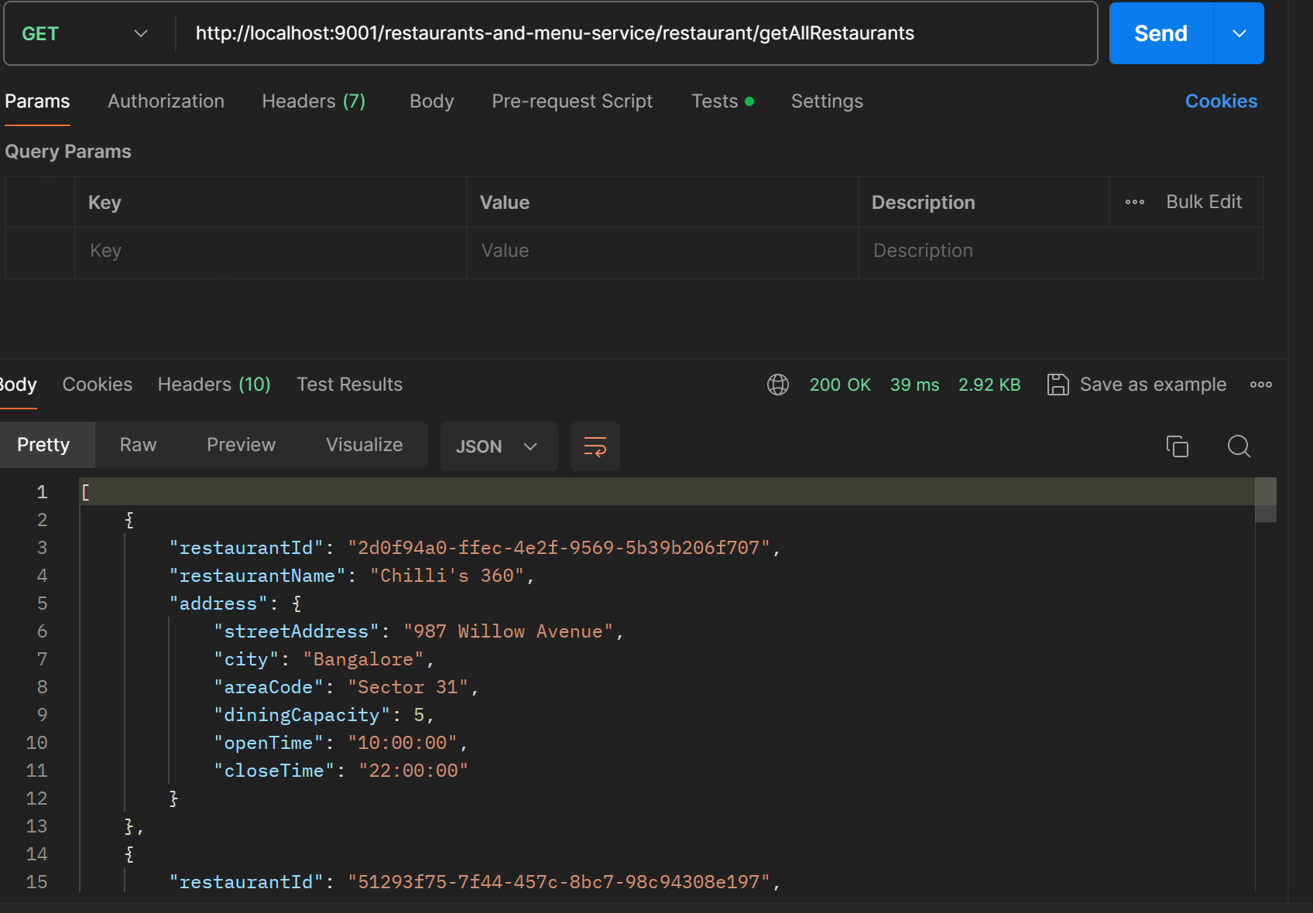

**Get Restaurant By Id:**

* This ApI helps to fetch a restaurant’s details and its address according to its id.

Method Type : GET

Request URL: /restaurant/getRestaurantById

In the input, we have to provide the Id of any of the restaurants received in the previous API’s output to fetch its corresponding details.

Response:

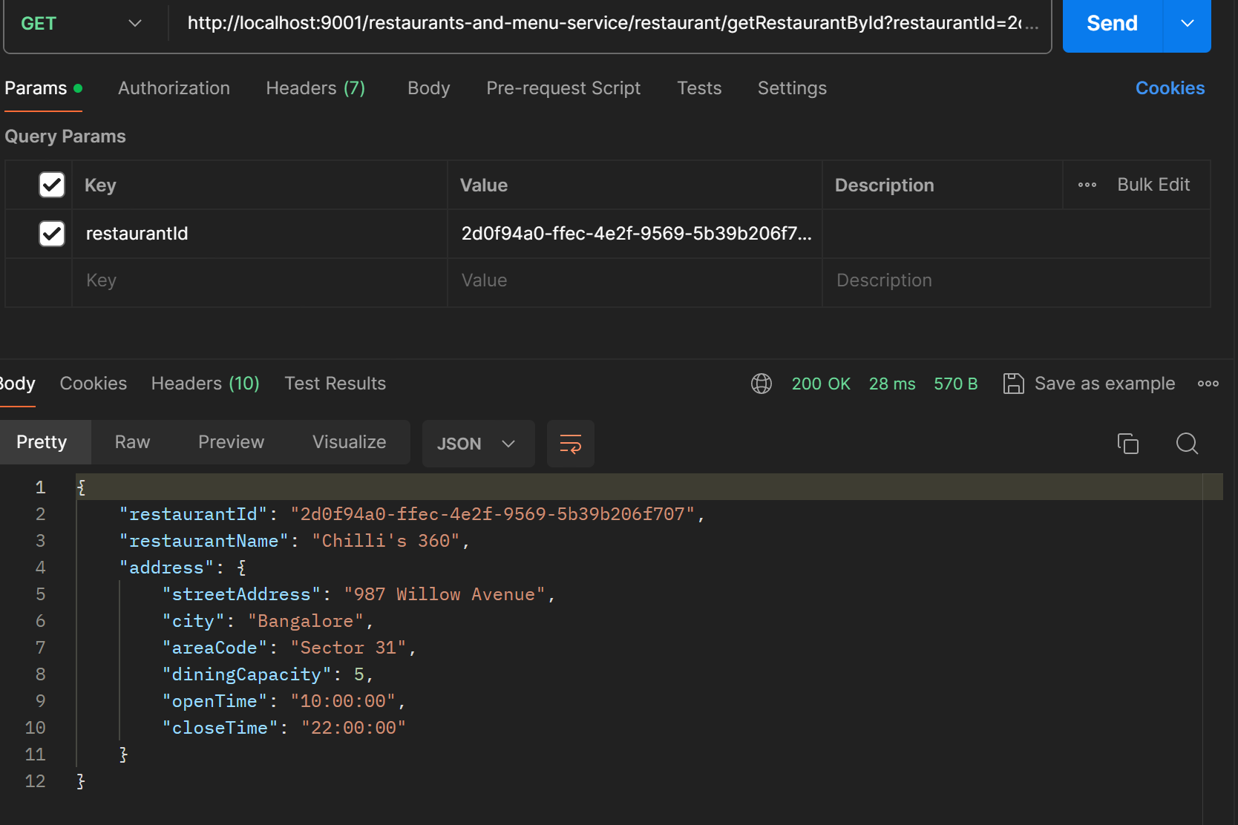

**Get Restaurant By Name**

* This API is used to fetch all the restaurants along with address details which have a particular name.

Method Type : GET

Request URL : restaurant/getRestaurantByName

Response :

[

    {

        "restaurantId": "422f9709-0eb3-41b8-9d0a-169207b66c74",

        "restaurantName": "Spice Paradise",

        "address": {

            "streetAddress": "456 Elm Avenue",

            "city": "Bangalore",

            "areaCode": "Sector 12",

            "diningCapacity": 3,

            "openTime": "10:00:00",

            "closeTime": "21:00:00"

        }

    },

    {

        "restaurantId": "956339a2-d94b-4f20-a7c6-33b6cee775fc",

        "restaurantName": "Spice Paradise",

        "address": {

            "streetAddress": "789 Oak Lane",

            "city": "Bangalore",

            "areaCode": "Sector 31",

            "diningCapacity": 7,

            "openTime": "11:00:00",

            "closeTime": "23:00:00"

        }

    }

]

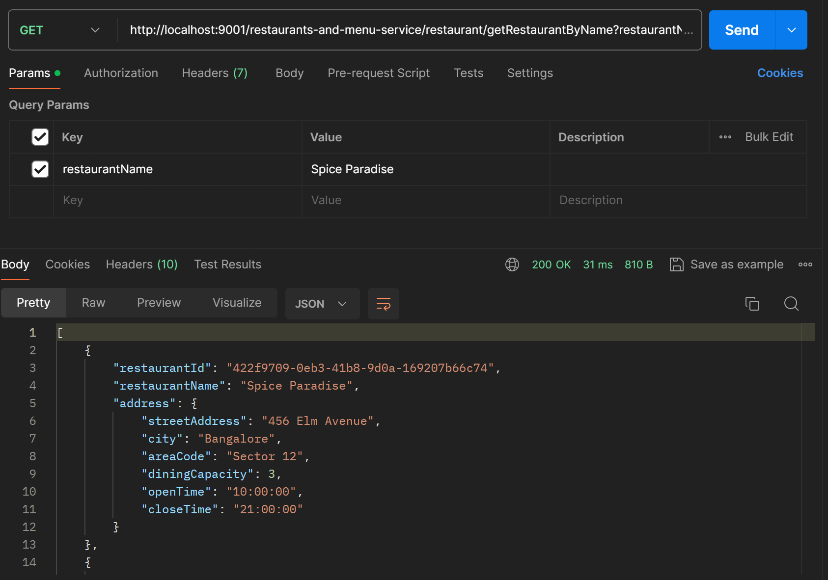

**Get Restaurant By Area Code**

* This API is used to fetch all the restaurants along with address details which have a particular name.

Method Type : GET

Request URL : restaurant/getRestaurantByAreaCode

Response :

[

    {

        "restaurantId": "2d0f94a0-ffec-4e2f-9569-5b39b206f707",

        "restaurantName": "Chilli's 360",

        "address": {

            "streetAddress": "987 Willow Avenue",

            "city": "Bangalore",

            "areaCode": "Sector 31",

            "diningCapacity": 5,

            "openTime": "10:00:00",

            "closeTime": "22:00:00"

        }

    },

    {

        "restaurantId": "956339a2-d94b-4f20-a7c6-33b6cee775fc",

        "restaurantName": "Spice Paradise",

        "address": {

            "streetAddress": "789 Oak Lane",

            "city": "Bangalore",

            "areaCode": "Sector 31",

            "diningCapacity": 7,

            "openTime": "11:00:00",

            "closeTime": "23:00:00"

        }

    }

]

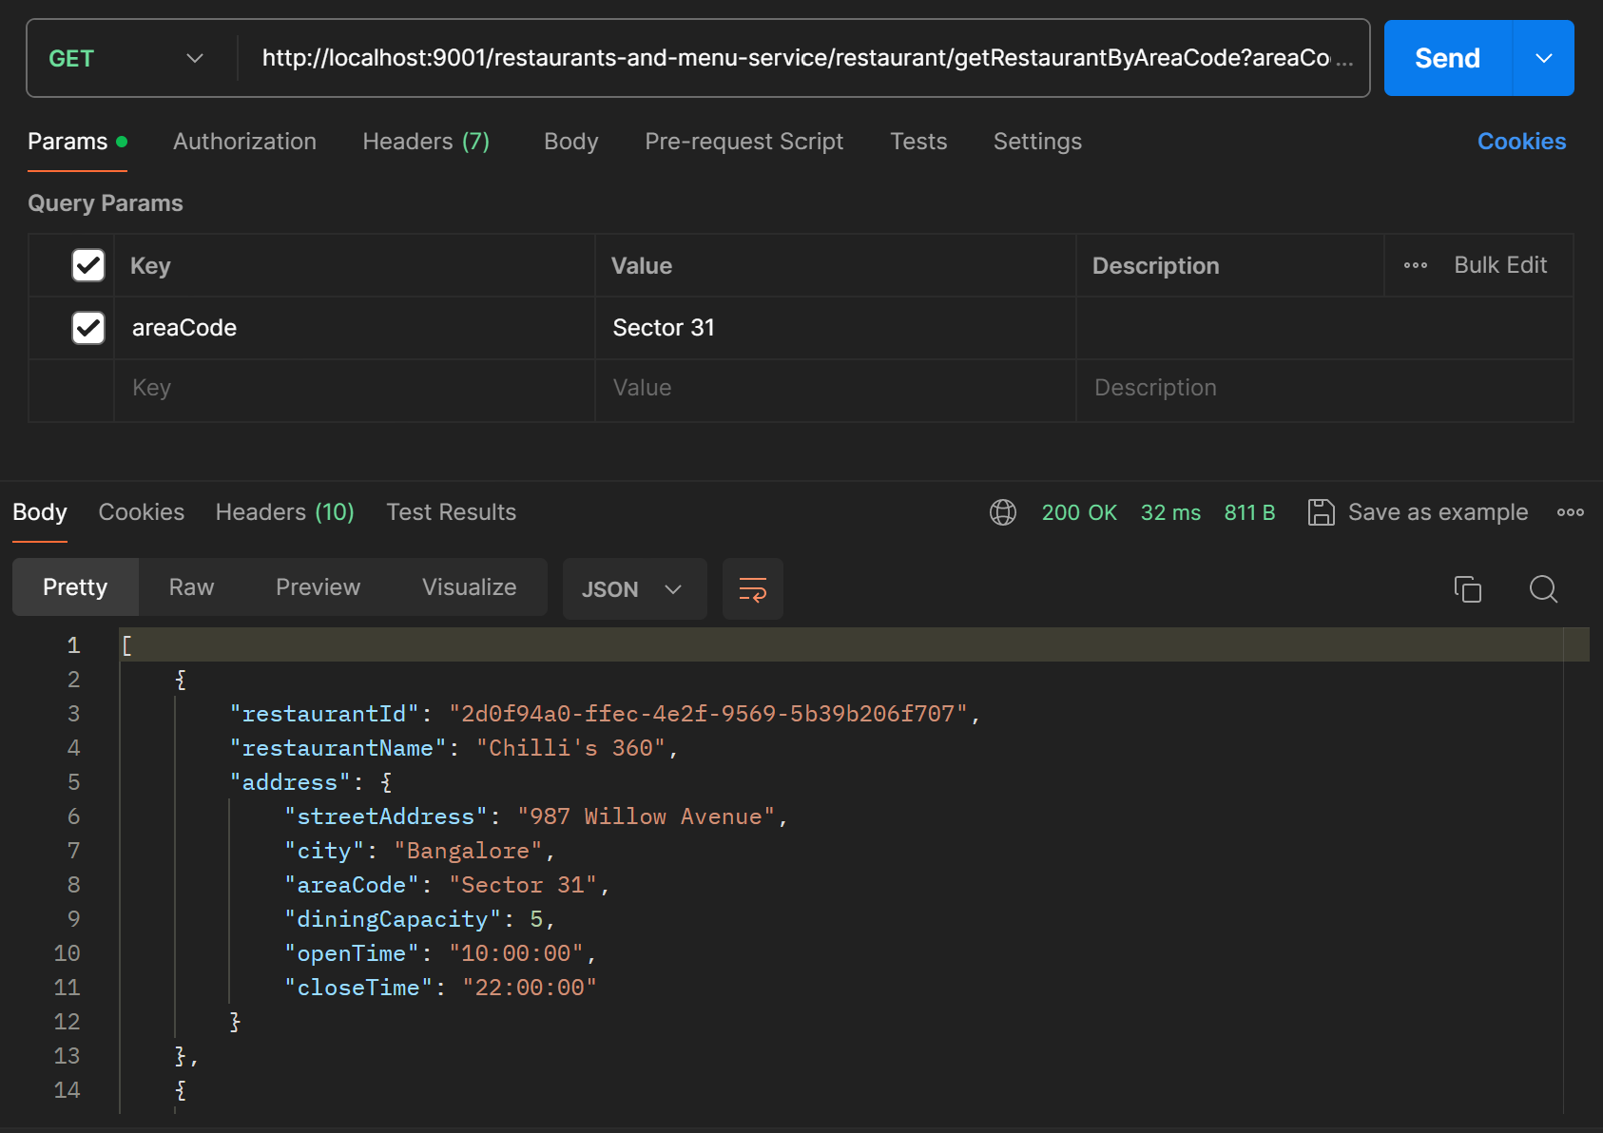

**Add Restaurant**

* This API can be used by admin or restaurant owners to register their restaurant on the portal. This helps to create a new restaurant entry in the inventory.

Method Type : POST

Request URL : restaurant/addRestaurant

Request Body :  
  
 {"restaurantName":"MJ's Dining",

"address":{

    "streetAddress":"Chester-le Street",

    "city":"Bangalore",

    "areaCode":"Sector 55"

},

"diningCapacity":"10",

"openTime":"10:45",

"closeTime":"2

Response :

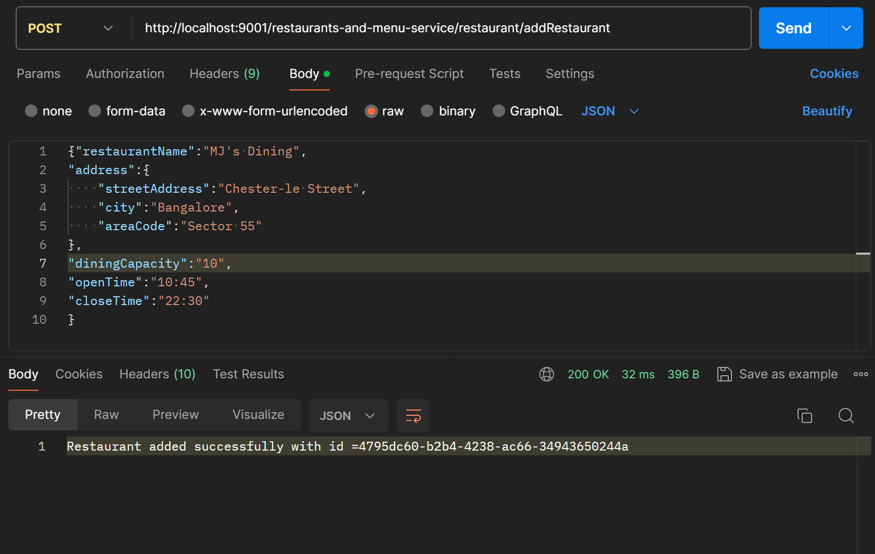

**Mark Favourite**

* This API can be used by users to mark the restaurants as favourite on the portal. In case of empty search, the favourite added restaurants will be shown at the top.
* In case the restaurant id doesn’t exist or the restaurant is already added to the favourite list by the user , the response will be shown accordingly.

Method Type : POST

Request Param : restaurantId

Request URL : restaurant/markFavourite

Response :

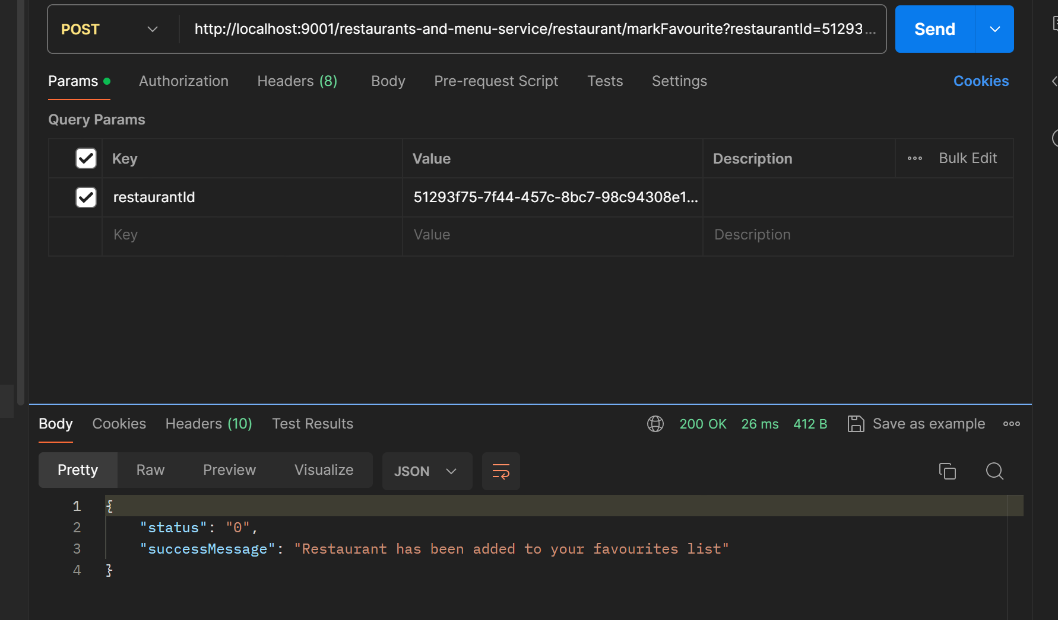

**User Search**

* Through this API, the user can search on the basis of restaurant name,area code or the food item in the portal . The API will respond as per the search entered in the respective fields.
* If all the fields are empty and the API is hit , the user will be able to view the restaurants added by him in the favourites list at the top along with its details.
* Also,once the user hits the API, the menu will be shown both restaurant-wise as well as the category wise according to the food category.

Method Type : POST

Request Param : restaurant,areaCode,foodItem

Request URL : food-menu/userSearch

Response :

{

    "favourites": [

        {

            "restaurantId": "2d0f94a0-ffec-4e2f-9569-5b39b206f707",

            "restaurantName": "Chilli's 360",

            "address": {

                "streetAddress": "987 Willow Avenue",

                "city": "Bangalore",

                "areaCode": "Sector 31",

                "diningCapacity": 5,

                "openTime": "10:00:00",

                "closeTime": "22:00:00"

            }

        },

        {

            "restaurantId": "51293f75-7f44-457c-8bc7-98c94308e197",

            "restaurantName": "Palette Pleasures",

            "address": {

                "streetAddress": "210 Maple Lane",

                "city": "Bangalore",

                "areaCode": "Sector 14",

                "diningCapacity": 4,

                "openTime": "09:00:00",

                "closeTime": "20:00:00"

            }

        }

    ],

    "foodMenuByRestaurants": [

        {

            "restaurant": {

                "restaurantId": "2d0f94a0-ffec-4e2f-9569-5b39b206f707",

                "restaurantName": "Chilli's 360",

                "address": {

                    "streetAddress": "987 Willow Avenue",

                    "city": "Bangalore",

                    "areaCode": "Sector 31",

                    "diningCapacity": 5,

                    "openTime": "10:00:00",

                    "closeTime": "22:00:00"

                }

            },

            "foodItems": [

                {

                    "itemId": "e6e540f5-c8d9-46ba-91bb-3e7a856fa55e",

                    "itemName": "Butter Chicken",

                    "category": "INDIAN_CUISINE",

                    "price": 11.99,

                    "description": "Tender chicken in a rich, creamy tomato-based curry",

                    "quantity": 3

                },

                {

                    "itemId": "bf6efe94-312a-4a73-a1e3-b7f348e421bd",

                    "itemName": "Margherita Pizza",

                    "category": "ITALIAN",

                    "price": 10.99,

                    "description": "Classic pizza with tomato, mozzarella, and basil",

                    "quantity": 1

                },

                {

                    "itemId": "dba606b6-5c78-4e91-983f-baf8ec2298d8",

                    "itemName": "Sushi Platter",

                    "category": "JAPANESE",

                    "price": 15.99,

                    "description": "Assorted sushi rolls and sashimi",

                    "quantity": 6

                },

                {

                    "itemId": "0eaae828-964d-472f-9552-471b49d20150",

                    "itemName": "Bibimbap",

                    "category": "KOREAN",

                    "price": 12.49,

                    "description": "Mixed rice with vegetables, meat, and spicy gochujang sauce",

                    "quantity": 1

                },

                {

                    "itemId": "9c0a764f-19a9-4d59-a81f-1bd95ed24a51",

                    "itemName": "Dal Makhani",

                    "category": "INDIAN_CUISINE",

                    "price": 9.99,

                    "description": "Slow-cooked black lentils in a creamy tomato-based sauce",

                    "quantity": 1

                },

                {

                    "itemId": "6b2062f5-d53a-4040-bc2e-dbec508b7c47",

                    "itemName": "Ravioli with Spinach and Ricotta",

                    "category": "ITALIAN",

                    "price": 13.99,

                    "description": "Homemade pasta filled with spinach and ricotta",

                    "quantity": 1

                },

                {

                    "itemId": "b0b94741-69f6-4cd2-8604-0db56ae9ffae",

                    "itemName": "Tempura",

                    "category": "JAPANESE",

                    "price": 12.99,

                    "description": "Battered and deep-fried seafood and vegetables",

                    "quantity": 8

                },

                {

                    "itemId": "43a9db35-b14f-40fd-aed6-2cf611cfce35",

                    "itemName": "Kimchi Fried Rice",

                    "category": "KOREAN",

                    "price": 11.99,

                    "description": "Fried rice with kimchi and assorted vegetables",

                    "quantity": 1

                }

            ]

        },

        {

            "restaurant": {

                "restaurantId": "51293f75-7f44-457c-8bc7-98c94308e197",

                "restaurantName": "Palette Pleasures",

                "address": {

                    "streetAddress": "210 Maple Lane",

                    "city": "Bangalore",

                    "areaCode": "Sector 14",

                    "diningCapacity": 4,

                    "openTime": "09:00:00",

                    "closeTime": "20:00:00"

                }

            },

            "foodItems": [

                {

                    "itemId": "d855930d-978a-4605-b72f-18ba440091cd",

                    "itemName": "Butter Chicken",

                    "category": "INDIAN_CUISINE",

                    "price": 11.99,

                    "description": "Tender chicken in a rich, creamy tomato-based curry",

                    "quantity": 4

                },

                {

                    "itemId": "60db6706-7426-490d-9560-c3d29a79cb45",

                    "itemName": "Margherita Pizza",

                    "category": "ITALIAN",

                    "price": 10.99,

                    "description": "Classic pizza with tomato, mozzarella, and basil",

                    "quantity": 2

                },

                {

                    "itemId": "330f70d4-5ae8-4019-9441-ac4c91d7aee7",

                    "itemName": "Sushi Platter",

                    "category": "JAPANESE",

                    "price": 15.99,

                    "description": "Assorted sushi rolls and sashimi",

                    "quantity": 5

                },

                {

                    "itemId": "7f0ae897-9ded-43f5-a382-77dad00189df",

                    "itemName": "Bibimbap",

                    "category": "KOREAN",

                    "price": 12.49,

                    "description": "Mixed rice with vegetables, meat, and spicy gochujang sauce",

                    "quantity": 3

                },

                {

                    "itemId": "75488a9f-fa9e-4064-a943-18c06f33dced",

                    "itemName": "Dal Makhani",

                    "category": "INDIAN_CUISINE",

                    "price": 9.99,

                    "description": "Slow-cooked black lentils in a creamy tomato-based sauce",

                    "quantity": 3

                },

                {

                    "itemId": "1f02aaac-7b28-49f8-ab85-afbac12bc8c2",

                    "itemName": "Ravioli with Spinach and Ricotta",

                    "category": "ITALIAN",

                    "price": 13.99,

                    "description": "Homemade pasta filled with spinach and ricotta",

                    "quantity": 1

                },

                {

                    "itemId": "7ef82422-c760-42cc-8c9a-c38a64bd54a0",

                    "itemName": "Tempura",

                    "category": "JAPANESE",

                    "price": 12.99,

                    "description": "Battered and deep-fried seafood and vegetables",

                    "quantity": 8

                },

                {

                    "itemId": "07425508-8fac-4996-ae47-3eb71a35d19c",

                    "itemName": "Kimchi Fried Rice",

                    "category": "KOREAN",

                    "price": 11.99,

                    "description": "Fried rice with kimchi and assorted vegetables",

                    "quantity": 1

                }

            ]

        },

        {

            "restaurant": {

                "restaurantId": "422f9709-0eb3-41b8-9d0a-169207b66c74",

                "restaurantName": "Spice Paradise",

                "address": {

                    "streetAddress": "456 Elm Avenue",

                    "city": "Bangalore",

                    "areaCode": "Sector 12",

                    "diningCapacity": 3,

                    "openTime": "10:00:00",

                    "closeTime": "21:00:00"

                }

            },

            "foodItems": [

                {

                    "itemId": "e692f4be-5210-4d05-9316-0d2b4c200ff1",

                    "itemName": "Butter Chicken",

                    "category": "INDIAN_CUISINE",

                    "price": 11.99,

                    "description": "Tender chicken in a rich, creamy tomato-based curry",

                    "quantity": 1

                },

                {

                    "itemId": "73e7b946-767b-4591-9e1e-40762b372eb1",

                    "itemName": "Margherita Pizza",

                    "category": "ITALIAN",

                    "price": 10.99,

                    "description": "Classic pizza with tomato, mozzarella, and basil",

                    "quantity": 1

                },

                {

                    "itemId": "a35c8ec3-2d4a-45b4-9879-ccf6c799f9cf",

                    "itemName": "Sushi Platter",

                    "category": "JAPANESE",

                    "price": 15.99,

                    "description": "Assorted sushi rolls and sashimi",

                    "quantity": 6

                },

                {

                    "itemId": "15bd51e2-267a-4180-be50-623a313f0563",

                    "itemName": "Bibimbap",

                    "category": "KOREAN",

                    "price": 12.49,

                    "description": "Mixed rice with vegetables, meat, and spicy gochujang sauce",

                    "quantity": 1

                }

            ]

        },

        {

            "restaurant": {

                "restaurantId": "956339a2-d94b-4f20-a7c6-33b6cee775fc",

                "restaurantName": "Spice Paradise",

                "address": {

                    "streetAddress": "789 Oak Lane",

                    "city": "Bangalore",

                    "areaCode": "Sector 31",

                    "diningCapacity": 7,

                    "openTime": "11:00:00",

                    "closeTime": "23:00:00"

                }

            },

            "foodItems": [

                {

                    "itemId": "e4617ab4-d5f4-4b66-a509-104aca37fe02",

                    "itemName": "Butter Chicken",

                    "category": "INDIAN_CUISINE",

                    "price": 11.99,

                    "description": "Tender chicken in a rich, creamy tomato-based curry",

                    "quantity": 1

                },

                {

                    "itemId": "9244e5ae-8923-4e2f-b251-563b193867e6",

                    "itemName": "Margherita Pizza",

                    "category": "ITALIAN",

                    "price": 10.99,

                    "description": "Classic pizza with tomato, mozzarella, and basil",

                    "quantity": 1

                },

                {

                    "itemId": "5713e48d-6bbc-410b-a17b-efbf68f4331c",

                    "itemName": "Sushi Platter",

                    "category": "JAPANESE",

                    "price": 15.99,

                    "description": "Assorted sushi rolls and sashimi",

                    "quantity": 6

                },

                {

                    "itemId": "08126b4f-422d-420d-9415-cc1dff73312d",

                    "itemName": "Bibimbap",

                    "category": "KOREAN",

                    "price": 12.49,

                    "description": "Mixed rice with vegetables, meat, and spicy gochujang sauce",

                    "quantity": 1

                },

                {

                    "itemId": "ead957b1-f0b1-4647-8777-9ff21b54586c",

                    "itemName": "Sashimi Platter",

                    "category": "JAPANESE",

                    "price": 18.99,

                    "description": "Fresh slices of raw fish served with wasabi and soy sauce",

                    "quantity": 6

                },

                {

                    "itemId": "7c300db5-80b2-4489-b930-19d2479490fc",

                    "itemName": "Japchae",

                    "category": "KOREAN",

                    "price": 13.99,

                    "description": "Stir-fried glass noodles with vegetables",

                    "quantity": 1

                },

                {

                    "itemId": "4efed6f3-4b5f-46a6-916d-d607b94a6f74",

                    "itemName": "Chole Bhature",

                    "category": "INDIAN_CUISINE",

                    "price": 9.49,

                    "description": "Chickpea curry served with deep-fried bread",

                    "quantity": 1

                },

                {

                    "itemId": "12588497-239a-4d1b-8875-6df6e2c7dd9f",

                    "itemName": "Tiramisu",

                    "category": "ITALIAN",

                    "price": 6.99,

                    "description": "Classic Italian dessert with coffee-soaked ladyfingers and mascarpone",

                    "quantity": 1

                }

            ]

        },

        {

            "restaurant": {

                "restaurantId": "5311b6d1-98c7-4d1a-9c7b-ce8feb6a53fc",

                "restaurantName": "Wholesome Delights",

                "address": {

                    "streetAddress": "321 Pine Road",

                    "city": "Bangalore",

                    "areaCode": "Sector 22",

                    "diningCapacity": 5,

                    "openTime": "10:00:00",

                    "closeTime": "21:00:00"

                }

            },

            "foodItems": [

                {

                    "itemId": "d5cb5dee-e8a8-47e5-9f5a-69fb9b331d20",

                    "itemName": "Butter Chicken",

                    "category": "INDIAN_CUISINE",

                    "price": 11.99,

                    "description": "Tender chicken in a rich, creamy tomato-based curry",

                    "quantity": 1

                },

                {

                    "itemId": "cf540516-a978-444c-aab4-2b05278021fd",

                    "itemName": "Margherita Pizza",

                    "category": "ITALIAN",

                    "price": 10.99,

                    "description": "Classic pizza with tomato, mozzarella, and basil",

                    "quantity": 1

                },

                {

                    "itemId": "0b26f8f0-a065-4d4d-ae10-ceb06ae9ac9c",

                    "itemName": "Sushi Platter",

                    "category": "JAPANESE",

                    "price": 15.99,

                    "description": "Assorted sushi rolls and sashimi",

                    "quantity": 6

                }

            ]

        },

        {

            "restaurant": {

                "restaurantId": "86f7daa1-504d-4c29-a2a8-657d7996f7c4",

                "restaurantName": "Gourmet Oasis",

                "address": {

                    "streetAddress": "210 Maple Lane",

                    "city": "Bangalore",

                    "areaCode": "Sector 14",

                    "diningCapacity": 6,

                    "openTime": "08:00:00",

                    "closeTime": "20:00:00"

                }

            },

            "foodItems": [

                {

                    "itemId": "752a9a65-8a50-4e0d-b3ae-e8e1818c1118",

                    "itemName": "Bibimbap",

                    "category": "KOREAN",

                    "price": 12.49,

                    "description": "Mixed rice with vegetables, meat, and spicy gochujang sauce",

                    "quantity": 1

                },

                {

                    "itemId": "7c69ae3a-e1d7-45b1-b4f3-a1ec24ec014b",

                    "itemName": "Chicken Curry",

                    "category": "INDIAN_CUISINE",

                    "price": 10.99,

                    "description": "Spicy chicken curry with aromatic spices",

                    "quantity": 1

                },

                {

                    "itemId": "0497a31a-0958-4654-9fe5-0925a4f78045",

                    "itemName": "Caprese Salad",

                    "category": "ITALIAN",

                    "price": 8.99,

                    "description": "Fresh mozzarella, tomatoes, and basil drizzled with balsamic glaze",

                    "quantity": 1

                },

                {

                    "itemId": "9cb2c6e5-6455-4a49-9ecb-b67ef4c58c3f",

                    "itemName": "Miso Soup",

                    "category": "JAPANESE",

                    "price": 6.99,

                    "description": "Traditional Japanese soup with tofu, seaweed, and green onions",

                    "quantity": 1

                }

            ]

        },

        {

            "restaurant": {

                "restaurantId": "539660ef-40b7-4e74-994b-504b8f6eae16",

                "restaurantName": "Mango Bistro",

                "address": {

                    "streetAddress": "654 Cedar Street",

                    "city": "Bangalore",

                    "areaCode": "Sector 22",

                    "diningCapacity": 3,

                    "openTime": "10:00:00",

                    "closeTime": "22:00:00"

                }

            },

            "foodItems": [

                {

                    "itemId": "f841c467-2003-4675-914c-eb385ce87d3a",

                    "itemName": "Butter Chicken",

                    "category": "INDIAN_CUISINE",

                    "price": 11.99,

                    "description": "Tender chicken in a rich, creamy tomato-based curry",

                    "quantity": 1

                },

                {

                    "itemId": "e08400f8-3c3a-44ee-9ec2-a0d3f706cf6d",

                    "itemName": "Margherita Pizza",

                    "category": "ITALIAN",

                    "price": 10.99,

                    "description": "Classic pizza with tomato, mozzarella, and basil",

                    "quantity": 1

                },

                {

                    "itemId": "8f16860e-16a4-4905-9471-108cba80d29a",

                    "itemName": "Sushi Platter",

                    "category": "JAPANESE",

                    "price": 15.99,

                    "description": "Assorted sushi rolls and sashimi",

                    "quantity": 6

                },

                {

                    "itemId": "27a6aef6-1b09-4feb-b9eb-3589e8912a2f",

                    "itemName": "Bibimbap",

                    "category": "KOREAN",

                    "price": 12.49,

                    "description": "Mixed rice with vegetables, meat, and spicy gochujang sauce",

                    "quantity": 1

                },

                {

                    "itemId": "4e7dd065-ade0-402b-9e9e-4775713a5710",

                    "itemName": "Chicken Curry",

                    "category": "INDIAN_CUISINE",

                    "price": 10.99,

                    "description": "Spicy chicken curry with aromatic spices",

                    "quantity": 1

                },

                {

                    "itemId": "7145d725-5d14-4e79-a206-440dfd908a92",

                    "itemName": "Caprese Salad",

                    "category": "ITALIAN",

                    "price": 8.99,

                    "description": "Fresh mozzarella, tomatoes, and basil drizzled with balsamic glaze",

                    "quantity": 1

                },

                {

                    "itemId": "d8a624f6-a885-4a76-96d4-b60802217010",

                    "itemName": "Miso Soup",

                    "category": "JAPANESE",

                    "price": 6.99,

                    "description": "Traditional Japanese soup with tofu, seaweed, and green onions",

                    "quantity": 1

                },

                {

                    "itemId": "820dc62b-fe33-41ac-8c64-4b2d17d00ece",

                    "itemName": "Bulgogi",

                    "category": "KOREAN",

                    "price": 14.49,

                    "description": "Marinated and grilled slices of beef",

                    "quantity": 1

                },

                {

                    "itemId": "362b8521-54bc-474a-8980-462fd12defd5",

                    "itemName": "Paneer Tikka",

                    "category": "INDIAN_CUISINE",

                    "price": 11.99,

                    "description": "Spiced and grilled paneer cubes",

                    "quantity": 6

                },

                {

                    "itemId": "392882d2-d1c7-45f7-9d33-416fab4aa339",

                    "itemName": "Fettuccine Alfredo",

                    "category": "ITALIAN",

                    "price": 12.99,

                    "description": "Creamy pasta with fettuccine and Alfredo sauce",

                    "quantity": 1

                },

                {

                    "itemId": "bf383ffb-9db7-41a7-b15d-42a5618992b8",

                    "itemName": "Sashimi Platter",

                    "category": "JAPANESE",

                    "price": 18.99,

                    "description": "Fresh slices of raw fish served with wasabi and soy sauce",

                    "quantity": 6

                },

                {

                    "itemId": "b4a5bc58-0ef5-4638-be8f-05f2d241e2dc",

                    "itemName": "Japchae",

                    "category": "KOREAN",

                    "price": 13.99,

                    "description": "Stir-fried glass noodles with vegetables",

                    "quantity": 1

                },

                {

                    "itemId": "ebbf8fe3-57d9-45f2-8e12-6daf49bbc940",

                    "itemName": "Chole Bhature",

                    "category": "INDIAN_CUISINE",

                    "price": 9.49,

                    "description": "Chickpea curry served with deep-fried bread",

                    "quantity": 1

                },

                {

                    "itemId": "5e75e337-7c13-468d-9d65-5f4734eec961",

                    "itemName": "Tiramisu",

                    "category": "ITALIAN",

                    "price": 6.99,

                    "description": "Classic Italian dessert with coffee-soaked ladyfingers and mascarpone",

                    "quantity": 1

                }

            ]

        },

        {

            "restaurant": {

                "restaurantId": "86816ab8-59f1-4bac-8334-2233a8edcde4",

                "restaurantName": "Sizzler's Delight",

                "address": {

                    "streetAddress": "130 Oak Lane",

                    "city": "Bangalore",

                    "areaCode": "Sector 14",

                    "diningCapacity": 2,

                    "openTime": "08:30:00",

                    "closeTime": "19:30:00"

                }

            },

            "foodItems": [

                {

                    "itemId": "520896e4-6b3b-40e3-8adf-828b9bb69ece",

                    "itemName": "Fettuccine Alfredo",

                    "category": "ITALIAN",

                    "price": 12.99,

                    "description": "Creamy pasta with fettuccine and Alfredo sauce",

                    "quantity": 1

                },

                {

                    "itemId": "0b30a8bf-8493-438f-9865-af2f1b229a9d",

                    "itemName": "Sashimi Platter",

                    "category": "JAPANESE",

                    "price": 18.99,

                    "description": "Fresh slices of raw fish served with wasabi and soy sauce",

                    "quantity": 6

                },

                {

                    "itemId": "aa506cde-9cb1-4799-b5c6-a08e7ac36619",

                    "itemName": "Japchae",

                    "category": "KOREAN",

                    "price": 13.99,

                    "description": "Stir-fried glass noodles with vegetables",

                    "quantity": 1

                },

                {

                    "itemId": "4bfd7110-4c4c-444e-873b-6e35e629037e",

                    "itemName": "Chole Bhature",

                    "category": "INDIAN_CUISINE",

                    "price": 9.49,

                    "description": "Chickpea curry served with deep-fried bread",

                    "quantity": 1

                },

                {

                    "itemId": "72d6a9f7-bcc9-44e9-aaf8-04d8aa7abb7c",

                    "itemName": "Tiramisu",

                    "category": "ITALIAN",

                    "price": 6.99,

                    "description": "Classic Italian dessert with coffee-soaked ladyfingers and mascarpone",

                    "quantity": 1

                }

            ]

        },

        {

            "restaurant": {

                "restaurantId": "65aced99-a469-4280-8596-2f19a33cc331",

                "restaurantName": "Cafe Fusion",

                "address": {

                    "streetAddress": "321 Pine Road",

                    "city": "Bangalore",

                    "areaCode": "Sector 22",

                    "diningCapacity": 8,

                    "openTime": "10:00:00",

                    "closeTime": "14:00:00"

                }

            },

            "foodItems": [

                {

                    "itemId": "99ec94fc-c029-4b2a-8706-778158f131e6",

                    "itemName": "Fettuccine Alfredo",

                    "category": "ITALIAN",

                    "price": 12.99,

                    "description": "Creamy pasta with fettuccine and Alfredo sauce",

                    "quantity": 1

                },

                {

                    "itemId": "c1e423fe-faef-4206-bc95-1def208ecfee",

                    "itemName": "Sashimi Platter",

                    "category": "JAPANESE",

                    "price": 18.99,

                    "description": "Fresh slices of raw fish served with wasabi and soy sauce",

                    "quantity": 6

                },

                {

                    "itemId": "26d87152-1169-49eb-aceb-ed3705cd6f4a",

                    "itemName": "Japchae",

                    "category": "KOREAN",

                    "price": 13.99,

                    "description": "Stir-fried glass noodles with vegetables",

                    "quantity": 1

                },

                {

                    "itemId": "b319b339-a669-4901-8fed-c66d84660859",

                    "itemName": "Chole Bhature",

                    "category": "INDIAN_CUISINE",

                    "price": 9.49,

                    "description": "Chickpea curry served with deep-fried bread",

                    "quantity": 1

                },

                {

                    "itemId": "676b4c3b-76bc-44b1-94b6-06bbf0e15b87",

                    "itemName": "Tiramisu",

                    "category": "ITALIAN",

                    "price": 6.99,

                    "description": "Classic Italian dessert with coffee-soaked ladyfingers and mascarpone",

                    "quantity": 1

                }

            ]

        }

    ],

    "categorizedFoodMenu": {

        "KOREAN": {

            "Spice Paradise": [

                {

                    "itemId": "15bd51e2-267a-4180-be50-623a313f0563",

                    "itemName": "Bibimbap",

                    "category": "KOREAN",

                    "price": 12.49,

                    "description": "Mixed rice with vegetables, meat, and spicy gochujang sauce",

                    "quantity": 1

                },

                {

                    "itemId": "08126b4f-422d-420d-9415-cc1dff73312d",

                    "itemName": "Bibimbap",

                    "category": "KOREAN",

                    "price": 12.49,

                    "description": "Mixed rice with vegetables, meat, and spicy gochujang sauce",

                    "quantity": 1

                },

                {

                    "itemId": "7c300db5-80b2-4489-b930-19d2479490fc",

                    "itemName": "Japchae",

                    "category": "KOREAN",

                    "price": 13.99,

                    "description": "Stir-fried glass noodles with vegetables",

                    "quantity": 1

                }

            ],

            "Sizzler's Delight": [

                {

                    "itemId": "aa506cde-9cb1-4799-b5c6-a08e7ac36619",

                    "itemName": "Japchae",

                    "category": "KOREAN",

                    "price": 13.99,

                    "description": "Stir-fried glass noodles with vegetables",

                    "quantity": 1

                }

            ],

            "Gourmet Oasis": [

                {

                    "itemId": "752a9a65-8a50-4e0d-b3ae-e8e1818c1118",

                    "itemName": "Bibimbap",

                    "category": "KOREAN",

                    "price": 12.49,

                    "description": "Mixed rice with vegetables, meat, and spicy gochujang sauce",

                    "quantity": 1

                }

            ],

            "Mango Bistro": [

                {

                    "itemId": "27a6aef6-1b09-4feb-b9eb-3589e8912a2f",

                    "itemName": "Bibimbap",

                    "category": "KOREAN",

                    "price": 12.49,

                    "description": "Mixed rice with vegetables, meat, and spicy gochujang sauce",

                    "quantity": 1

                },

                {

                    "itemId": "820dc62b-fe33-41ac-8c64-4b2d17d00ece",

                    "itemName": "Bulgogi",

                    "category": "KOREAN",

                    "price": 14.49,

                    "description": "Marinated and grilled slices of beef",

                    "quantity": 1

                },

                {

                    "itemId": "b4a5bc58-0ef5-4638-be8f-05f2d241e2dc",

                    "itemName": "Japchae",

                    "category": "KOREAN",

                    "price": 13.99,

                    "description": "Stir-fried glass noodles with vegetables",

                    "quantity": 1

                }

            ],

            "Palette Pleasures": [

                {

                    "itemId": "7f0ae897-9ded-43f5-a382-77dad00189df",

                    "itemName": "Bibimbap",

                    "category": "KOREAN",

                    "price": 12.49,

                    "description": "Mixed rice with vegetables, meat, and spicy gochujang sauce",

                    "quantity": 3

                },

                {

                    "itemId": "07425508-8fac-4996-ae47-3eb71a35d19c",

                    "itemName": "Kimchi Fried Rice",

                    "category": "KOREAN",

                    "price": 11.99,

                    "description": "Fried rice with kimchi and assorted vegetables",

                    "quantity": 1

                }

            ],

            "Cafe Fusion": [

                {

                    "itemId": "26d87152-1169-49eb-aceb-ed3705cd6f4a",

                    "itemName": "Japchae",

                    "category": "KOREAN",

                    "price": 13.99,

                    "description": "Stir-fried glass noodles with vegetables",

                    "quantity": 1

                }

            ],

            "Chilli's 360": [

                {

                    "itemId": "0eaae828-964d-472f-9552-471b49d20150",

                    "itemName": "Bibimbap",

                    "category": "KOREAN",

                    "price": 12.49,

                    "description": "Mixed rice with vegetables, meat, and spicy gochujang sauce",

                    "quantity": 1

                },

                {

                    "itemId": "43a9db35-b14f-40fd-aed6-2cf611cfce35",

                    "itemName": "Kimchi Fried Rice",

                    "category": "KOREAN",

                    "price": 11.99,

                    "description": "Fried rice with kimchi and assorted vegetables",

                    "quantity": 1

                }

            ]

        },

        "JAPANESE": {

            "Spice Paradise": [

                {

                    "itemId": "a35c8ec3-2d4a-45b4-9879-ccf6c799f9cf",

                    "itemName": "Sushi Platter",

                    "category": "JAPANESE",

                    "price": 15.99,

                    "description": "Assorted sushi rolls and sashimi",

                    "quantity": 6

                },

                {

                    "itemId": "5713e48d-6bbc-410b-a17b-efbf68f4331c",

                    "itemName": "Sushi Platter",

                    "category": "JAPANESE",

                    "price": 15.99,

                    "description": "Assorted sushi rolls and sashimi",

                    "quantity": 6

                },

                {

                    "itemId": "ead957b1-f0b1-4647-8777-9ff21b54586c",

                    "itemName": "Sashimi Platter",

                    "category": "JAPANESE",

                    "price": 18.99,

                    "description": "Fresh slices of raw fish served with wasabi and soy sauce",

                    "quantity": 6

                }

            ],

            "Sizzler's Delight": [

                {

                    "itemId": "0b30a8bf-8493-438f-9865-af2f1b229a9d",

                    "itemName": "Sashimi Platter",

                    "category": "JAPANESE",

                    "price": 18.99,

                    "description": "Fresh slices of raw fish served with wasabi and soy sauce",

                    "quantity": 6

                }

            ],

            "Gourmet Oasis": [

                {

                    "itemId": "9cb2c6e5-6455-4a49-9ecb-b67ef4c58c3f",

                    "itemName": "Miso Soup",

                    "category": "JAPANESE",

                    "price": 6.99,

                    "description": "Traditional Japanese soup with tofu, seaweed, and green onions",

                    "quantity": 1

                }

            ],

            "Mango Bistro": [

                {

                    "itemId": "8f16860e-16a4-4905-9471-108cba80d29a",

                    "itemName": "Sushi Platter",

                    "category": "JAPANESE",

                    "price": 15.99,

                    "description": "Assorted sushi rolls and sashimi",

                    "quantity": 6

                },

                {

                    "itemId": "d8a624f6-a885-4a76-96d4-b60802217010",

                    "itemName": "Miso Soup",

                    "category": "JAPANESE",

                    "price": 6.99,

                    "description": "Traditional Japanese soup with tofu, seaweed, and green onions",

                    "quantity": 1

                },

                {

                    "itemId": "bf383ffb-9db7-41a7-b15d-42a5618992b8",

                    "itemName": "Sashimi Platter",

                    "category": "JAPANESE",

                    "price": 18.99,

                    "description": "Fresh slices of raw fish served with wasabi and soy sauce",

                    "quantity": 6

                }

            ],

            "Wholesome Delights": [

                {

                    "itemId": "0b26f8f0-a065-4d4d-ae10-ceb06ae9ac9c",

                    "itemName": "Sushi Platter",

                    "category": "JAPANESE",

                    "price": 15.99,

                    "description": "Assorted sushi rolls and sashimi",

                    "quantity": 6

                }

            ],

            "Palette Pleasures": [

                {

                    "itemId": "330f70d4-5ae8-4019-9441-ac4c91d7aee7",

                    "itemName": "Sushi Platter",

                    "category": "JAPANESE",

                    "price": 15.99,

                    "description": "Assorted sushi rolls and sashimi",

                    "quantity": 5

                },

                {

                    "itemId": "7ef82422-c760-42cc-8c9a-c38a64bd54a0",

                    "itemName": "Tempura",

                    "category": "JAPANESE",

                    "price": 12.99,

                    "description": "Battered and deep-fried seafood and vegetables",

                    "quantity": 8

                }

            ],

            "Cafe Fusion": [

                {

                    "itemId": "c1e423fe-faef-4206-bc95-1def208ecfee",

                    "itemName": "Sashimi Platter",

                    "category": "JAPANESE",

                    "price": 18.99,

                    "description": "Fresh slices of raw fish served with wasabi and soy sauce",

                    "quantity": 6

                }

            ],

            "Chilli's 360": [

                {

                    "itemId": "dba606b6-5c78-4e91-983f-baf8ec2298d8",

                    "itemName": "Sushi Platter",

                    "category": "JAPANESE",

                    "price": 15.99,

                    "description": "Assorted sushi rolls and sashimi",

                    "quantity": 6

                },

                {

                    "itemId": "b0b94741-69f6-4cd2-8604-0db56ae9ffae",

                    "itemName": "Tempura",

                    "category": "JAPANESE",

                    "price": 12.99,

                    "description": "Battered and deep-fried seafood and vegetables",

                    "quantity": 8

                }

            ]

        },

        "INDIAN_CUISINE": {

            "Spice Paradise": [

                {

                    "itemId": "e692f4be-5210-4d05-9316-0d2b4c200ff1",

                    "itemName": "Butter Chicken",

                    "category": "INDIAN_CUISINE",

                    "price": 11.99,

                    "description": "Tender chicken in a rich, creamy tomato-based curry",

                    "quantity": 1

                },

                {

                    "itemId": "e4617ab4-d5f4-4b66-a509-104aca37fe02",

                    "itemName": "Butter Chicken",

                    "category": "INDIAN_CUISINE",

                    "price": 11.99,

                    "description": "Tender chicken in a rich, creamy tomato-based curry",

                    "quantity": 1

                },

                {

                    "itemId": "4efed6f3-4b5f-46a6-916d-d607b94a6f74",

                    "itemName": "Chole Bhature",

                    "category": "INDIAN_CUISINE",

                    "price": 9.49,

                    "description": "Chickpea curry served with deep-fried bread",

                    "quantity": 1

                }

            ],

            "Sizzler's Delight": [

                {

                    "itemId": "4bfd7110-4c4c-444e-873b-6e35e629037e",

                    "itemName": "Chole Bhature",

                    "category": "INDIAN_CUISINE",

                    "price": 9.49,

                    "description": "Chickpea curry served with deep-fried bread",

                    "quantity": 1

                }

            ],

            "Gourmet Oasis": [

                {

                    "itemId": "7c69ae3a-e1d7-45b1-b4f3-a1ec24ec014b",

                    "itemName": "Chicken Curry",

                    "category": "INDIAN_CUISINE",

                    "price": 10.99,

                    "description": "Spicy chicken curry with aromatic spices",

                    "quantity": 1

                }

            ],

            "Mango Bistro": [

                {

                    "itemId": "f841c467-2003-4675-914c-eb385ce87d3a",

                    "itemName": "Butter Chicken",

                    "category": "INDIAN_CUISINE",

                    "price": 11.99,

                    "description": "Tender chicken in a rich, creamy tomato-based curry",

                    "quantity": 1

                },

                {

                    "itemId": "4e7dd065-ade0-402b-9e9e-4775713a5710",

                    "itemName": "Chicken Curry",

                    "category": "INDIAN_CUISINE",

                    "price": 10.99,

                    "description": "Spicy chicken curry with aromatic spices",

                    "quantity": 1

                },

                {

                    "itemId": "362b8521-54bc-474a-8980-462fd12defd5",

                    "itemName": "Paneer Tikka",

                    "category": "INDIAN_CUISINE",

                    "price": 11.99,

                    "description": "Spiced and grilled paneer cubes",

                    "quantity": 6

                },

                {

                    "itemId": "ebbf8fe3-57d9-45f2-8e12-6daf49bbc940",

                    "itemName": "Chole Bhature",

                    "category": "INDIAN_CUISINE",

                    "price": 9.49,

                    "description": "Chickpea curry served with deep-fried bread",

                    "quantity": 1

                }

            ],

            "Wholesome Delights": [

                {

                    "itemId": "d5cb5dee-e8a8-47e5-9f5a-69fb9b331d20",

                    "itemName": "Butter Chicken",

                    "category": "INDIAN_CUISINE",

                    "price": 11.99,

                    "description": "Tender chicken in a rich, creamy tomato-based curry",

                    "quantity": 1

                }

            ],

            "Palette Pleasures": [

                {

                    "itemId": "d855930d-978a-4605-b72f-18ba440091cd",

                    "itemName": "Butter Chicken",

                    "category": "INDIAN_CUISINE",

                    "price": 11.99,

                    "description": "Tender chicken in a rich, creamy tomato-based curry",

                    "quantity": 4

                },

                {

                    "itemId": "75488a9f-fa9e-4064-a943-18c06f33dced",

                    "itemName": "Dal Makhani",

                    "category": "INDIAN_CUISINE",

                    "price": 9.99,

                    "description": "Slow-cooked black lentils in a creamy tomato-based sauce",

                    "quantity": 3

                }

            ],

            "Cafe Fusion": [

                {

                    "itemId": "b319b339-a669-4901-8fed-c66d84660859",

                    "itemName": "Chole Bhature",

                    "category": "INDIAN_CUISINE",

                    "price": 9.49,

                    "description": "Chickpea curry served with deep-fried bread",

                    "quantity": 1

                }

            ],

            "Chilli's 360": [

                {

                    "itemId": "e6e540f5-c8d9-46ba-91bb-3e7a856fa55e",

                    "itemName": "Butter Chicken",

                    "category": "INDIAN_CUISINE",

                    "price": 11.99,

                    "description": "Tender chicken in a rich, creamy tomato-based curry",

                    "quantity": 3

                },

                {

                    "itemId": "9c0a764f-19a9-4d59-a81f-1bd95ed24a51",

                    "itemName": "Dal Makhani",

                    "category": "INDIAN_CUISINE",

                    "price": 9.99,

                    "description": "Slow-cooked black lentils in a creamy tomato-based sauce",

                    "quantity": 1

                }

            ]

        },

        "ITALIAN": {

            "Spice Paradise": [

                {

                    "itemId": "73e7b946-767b-4591-9e1e-40762b372eb1",

                    "itemName": "Margherita Pizza",

                    "category": "ITALIAN",

                    "price": 10.99,

                    "description": "Classic pizza with tomato, mozzarella, and basil",

                    "quantity": 1

                },

                {

                    "itemId": "9244e5ae-8923-4e2f-b251-563b193867e6",

                    "itemName": "Margherita Pizza",

                    "category": "ITALIAN",

                    "price": 10.99,

                    "description": "Classic pizza with tomato, mozzarella, and basil",

                    "quantity": 1

                },

                {

                    "itemId": "12588497-239a-4d1b-8875-6df6e2c7dd9f",

                    "itemName": "Tiramisu",

                    "category": "ITALIAN",

                    "price": 6.99,

                    "description": "Classic Italian dessert with coffee-soaked ladyfingers and mascarpone",

                    "quantity": 1

                }

            ],

            "Sizzler's Delight": [

                {

                    "itemId": "520896e4-6b3b-40e3-8adf-828b9bb69ece",

                    "itemName": "Fettuccine Alfredo",

                    "category": "ITALIAN",

                    "price": 12.99,

                    "description": "Creamy pasta with fettuccine and Alfredo sauce",

                    "quantity": 1

                },

                {

                    "itemId": "72d6a9f7-bcc9-44e9-aaf8-04d8aa7abb7c",

                    "itemName": "Tiramisu",

                    "category": "ITALIAN",

                    "price": 6.99,

                    "description": "Classic Italian dessert with coffee-soaked ladyfingers and mascarpone",

                    "quantity": 1

                }

            ],

            "Gourmet Oasis": [

                {

                    "itemId": "0497a31a-0958-4654-9fe5-0925a4f78045",

                    "itemName": "Caprese Salad",

                    "category": "ITALIAN",

                    "price": 8.99,

                    "description": "Fresh mozzarella, tomatoes, and basil drizzled with balsamic glaze",

                    "quantity": 1

                }

            ],

            "Mango Bistro": [

                {

                    "itemId": "e08400f8-3c3a-44ee-9ec2-a0d3f706cf6d",

                    "itemName": "Margherita Pizza",

                    "category": "ITALIAN",

                    "price": 10.99,

                    "description": "Classic pizza with tomato, mozzarella, and basil",

                    "quantity": 1

                },

                {

                    "itemId": "7145d725-5d14-4e79-a206-440dfd908a92",

                    "itemName": "Caprese Salad",

                    "category": "ITALIAN",

                    "price": 8.99,

                    "description": "Fresh mozzarella, tomatoes, and basil drizzled with balsamic glaze",

                    "quantity": 1

                },

                {

                    "itemId": "392882d2-d1c7-45f7-9d33-416fab4aa339",

                    "itemName": "Fettuccine Alfredo",

                    "category": "ITALIAN",

                    "price": 12.99,

                    "description": "Creamy pasta with fettuccine and Alfredo sauce",

                    "quantity": 1

                },

                {

                    "itemId": "5e75e337-7c13-468d-9d65-5f4734eec961",

                    "itemName": "Tiramisu",

                    "category": "ITALIAN",

                    "price": 6.99,

                    "description": "Classic Italian dessert with coffee-soaked ladyfingers and mascarpone",

                    "quantity": 1

                }

            ],

            "Wholesome Delights": [

                {

                    "itemId": "cf540516-a978-444c-aab4-2b05278021fd",

                    "itemName": "Margherita Pizza",

                    "category": "ITALIAN",

                    "price": 10.99,

                    "description": "Classic pizza with tomato, mozzarella, and basil",

                    "quantity": 1

                }

            ],

            "Palette Pleasures": [

                {

                    "itemId": "60db6706-7426-490d-9560-c3d29a79cb45",

                    "itemName": "Margherita Pizza",

                    "category": "ITALIAN",

                    "price": 10.99,

                    "description": "Classic pizza with tomato, mozzarella, and basil",

                    "quantity": 2

                },

                {

                    "itemId": "1f02aaac-7b28-49f8-ab85-afbac12bc8c2",

                    "itemName": "Ravioli with Spinach and Ricotta",

                    "category": "ITALIAN",

                    "price": 13.99,

                    "description": "Homemade pasta filled with spinach and ricotta",

                    "quantity": 1

                }

            ],

            "Cafe Fusion": [

                {

                    "itemId": "99ec94fc-c029-4b2a-8706-778158f131e6",

                    "itemName": "Fettuccine Alfredo",

                    "category": "ITALIAN",

                    "price": 12.99,

                    "description": "Creamy pasta with fettuccine and Alfredo sauce",

                    "quantity": 1

                },

                {

                    "itemId": "676b4c3b-76bc-44b1-94b6-06bbf0e15b87",

                    "itemName": "Tiramisu",

                    "category": "ITALIAN",

                    "price": 6.99,

                    "description": "Classic Italian dessert with coffee-soaked ladyfingers and mascarpone",

                    "quantity": 1

                }

            ],

            "Chilli's 360": [

                {

                    "itemId": "bf6efe94-312a-4a73-a1e3-b7f348e421bd",

                    "itemName": "Margherita Pizza",

                    "category": "ITALIAN",

                    "price": 10.99,

                    "description": "Classic pizza with tomato, mozzarella, and basil",

                    "quantity": 1

                },

                {

                    "itemId": "6b2062f5-d53a-4040-bc2e-dbec508b7c47",

                    "itemName": "Ravioli with Spinach and Ricotta",

                    "category": "ITALIAN",

                    "price": 13.99,

                    "description": "Homemade pasta filled with spinach and ricotta",

                    "quantity": 1

                }

            ]

        }

    }

}

As you can see in the response, first the favourites list appears because its an empty search , then the menu is shown restaurant wise for the restaurants and then the food items are shown categorically.  
  
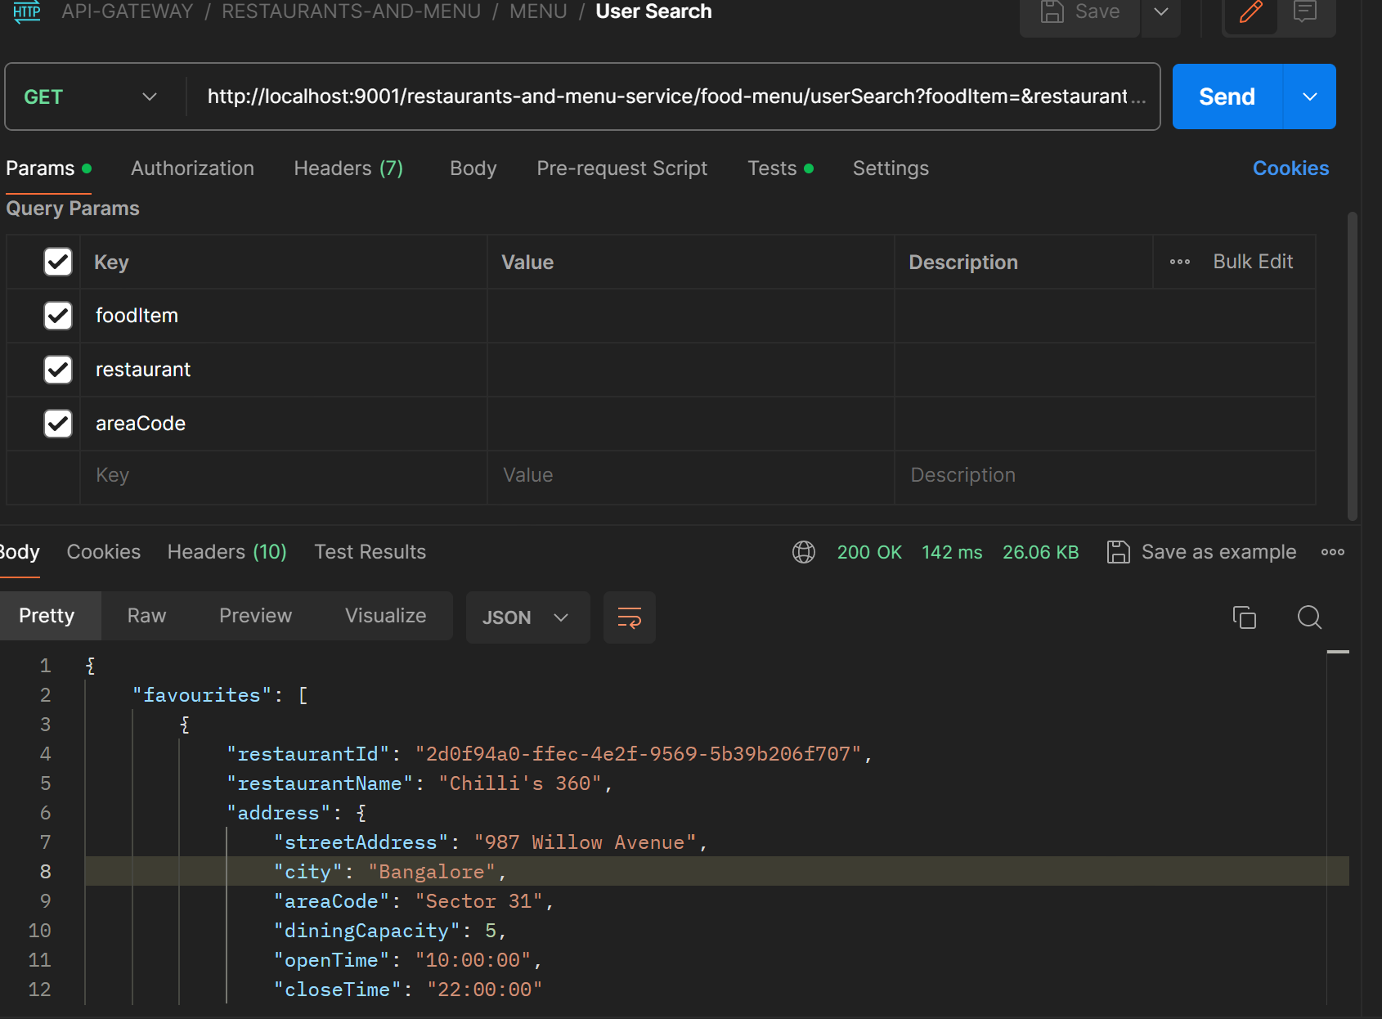

**Get Menu By Restaurant Id**

* This api is used for getting the menu for a particular restaurant through its ID.

If the restaurant id is invalid, it will show the error message accordingly.

Method Type : GET

Request Param : restaurantId

Request URL : food-menu/getRestaurantMenu

Response :

{

    "restaurant": {

        "restaurantId": "2d0f94a0-ffec-4e2f-9569-5b39b206f707",

        "restaurantName": "Chilli's 360",

        "address": {

            "streetAddress": "987 Willow Avenue",

            "city": "Bangalore",

            "areaCode": "Sector 31",

            "diningCapacity": 5,

            "openTime": "10:00:00",

            "closeTime": "22:00:00"

        }

    },

    "foodItems": [

        {

            "itemId": "e6e540f5-c8d9-46ba-91bb-3e7a856fa55e",

            "itemName": "Butter Chicken",

            "category": "INDIAN_CUISINE",

            "price": 11.99,

            "description": "Tender chicken in a rich, creamy tomato-based curry",

            "quantity": 3

        },

        {

            "itemId": "bf6efe94-312a-4a73-a1e3-b7f348e421bd",

            "itemName": "Margherita Pizza",

            "category": "ITALIAN",

            "price": 10.99,

            "description": "Classic pizza with tomato, mozzarella, and basil",

            "quantity": 1

        },

        {

            "itemId": "dba606b6-5c78-4e91-983f-baf8ec2298d8",

            "itemName": "Sushi Platter",

            "category": "JAPANESE",

            "price": 15.99,

            "description": "Assorted sushi rolls and sashimi",

            "quantity": 6

        },

        {

            "itemId": "0eaae828-964d-472f-9552-471b49d20150",

            "itemName": "Bibimbap",

            "category": "KOREAN",

            "price": 12.49,

            "description": "Mixed rice with vegetables, meat, and spicy gochujang sauce",

            "quantity": 1

        },

        {

            "itemId": "9c0a764f-19a9-4d59-a81f-1bd95ed24a51",

            "itemName": "Dal Makhani",

            "category": "INDIAN_CUISINE",

            "price": 9.99,

            "description": "Slow-cooked black lentils in a creamy tomato-based sauce",

            "quantity": 1

        },

        {

            "itemId": "6b2062f5-d53a-4040-bc2e-dbec508b7c47",

            "itemName": "Ravioli with Spinach and Ricotta",

            "category": "ITALIAN",

            "price": 13.99,

            "description": "Homemade pasta filled with spinach and ricotta",

            "quantity": 1

        },

        {

            "itemId": "b0b94741-69f6-4cd2-8604-0db56ae9ffae",

            "itemName": "Tempura",

            "category": "JAPANESE",

            "price": 12.99,

            "description": "Battered and deep-fried seafood and vegetables",

            "quantity": 8

        },

        {

            "itemId": "43a9db35-b14f-40fd-aed6-2cf611cfce35",

            "itemName": "Kimchi Fried Rice",

            "category": "KOREAN",

            "price": 11.99,

            "description": "Fried rice with kimchi and assorted vegetables",

            "quantity": 1

        }

    ]

}

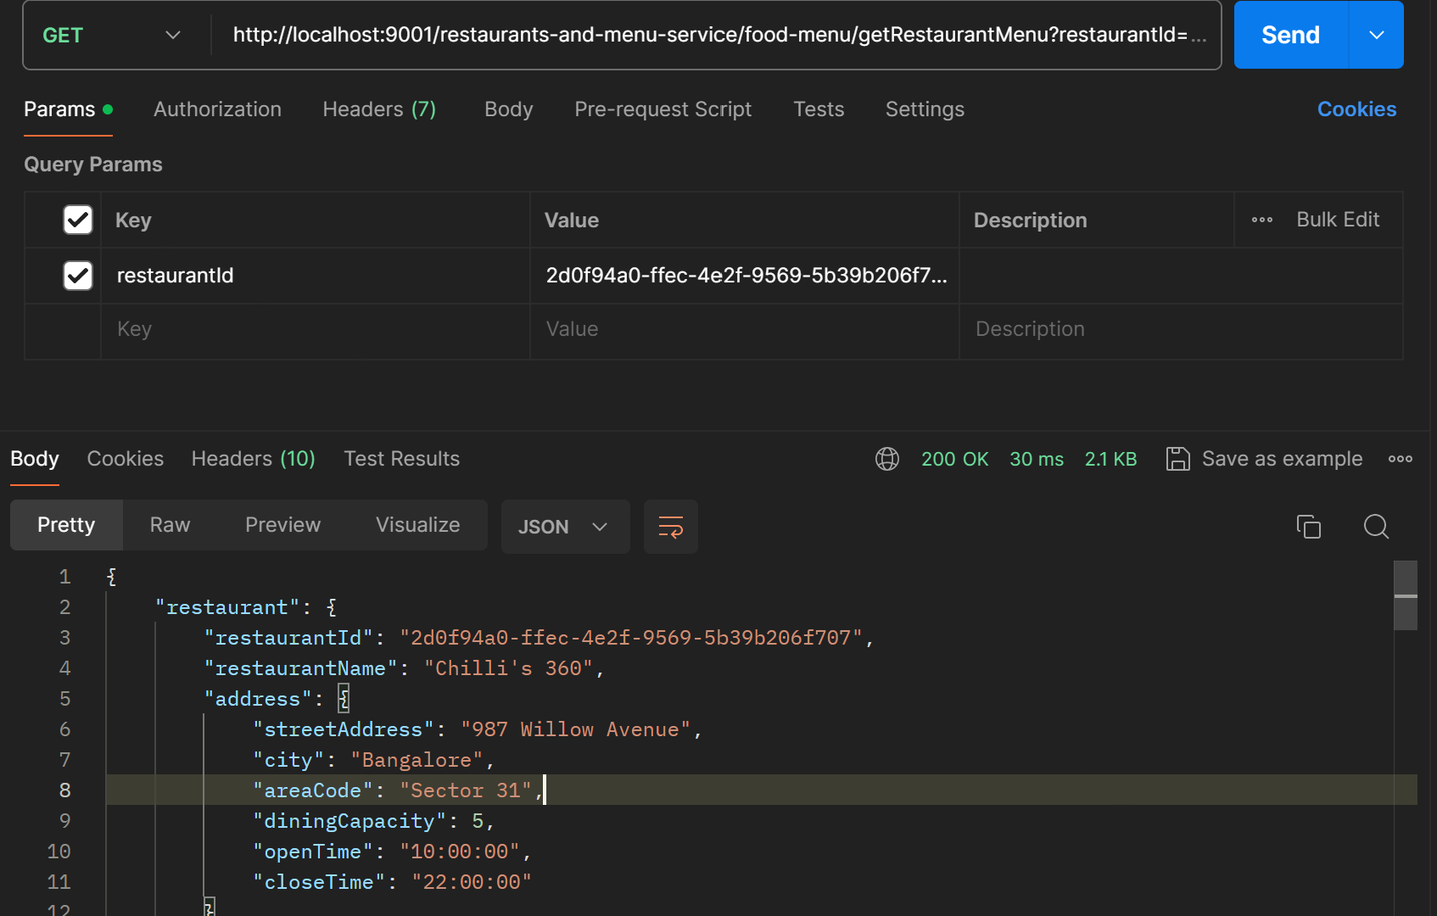

**Add Item to Restaurant Menu**

* This api is used by restaurant owners or admin for adding the items to the menu for a newly added restaurant (using addRestaurant api ) or the existing ones.

Method Type : POST

Request Body:

{

    "itemName":"MJ special",

    "category":"JAPANESE",

    "price":20.0,

    "description":"It is a special dish",

    "quantity":10

}

Request URL : food-menu/addItemsToRestaurantMenu

Response:

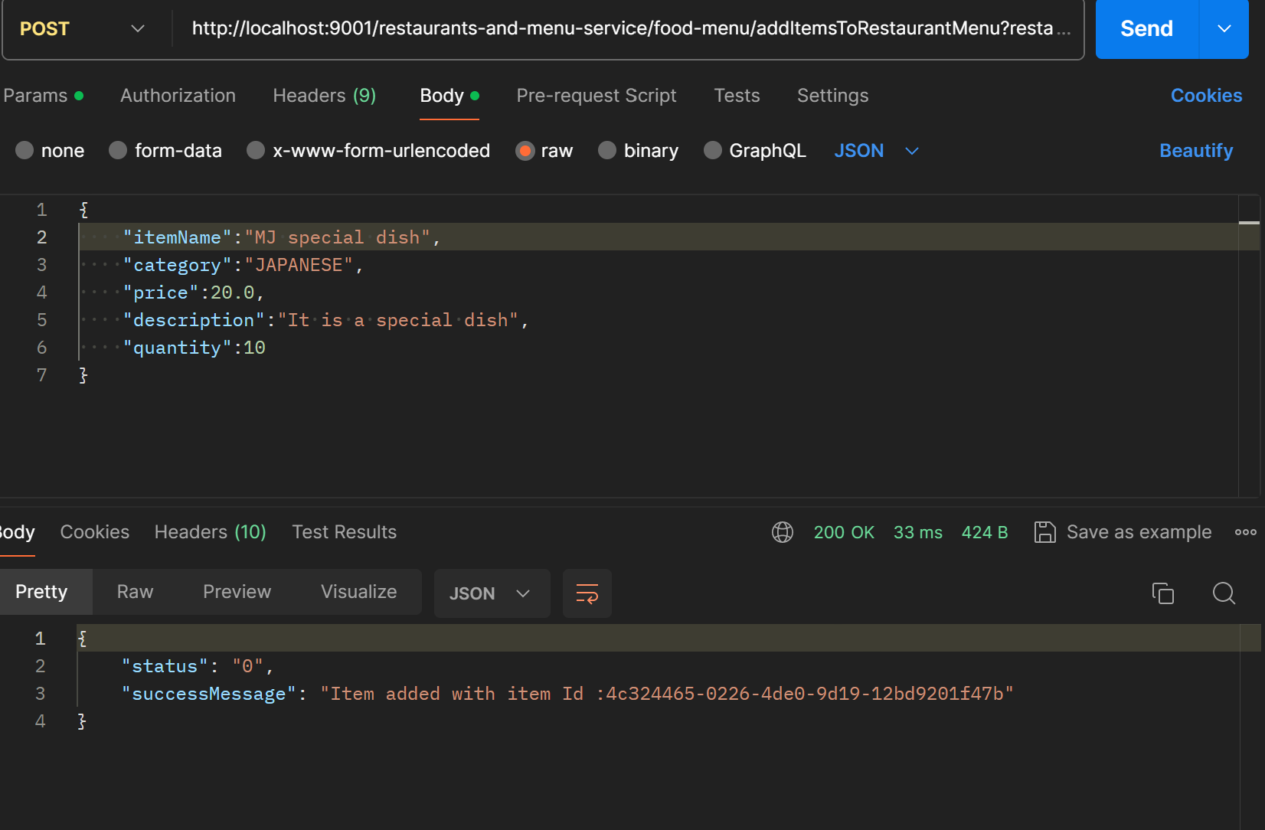

**Get Item Details by Item Id**

* This Api mainly serves the internal purpose and used during communication with delivery service to fetch food item details by item Id.

Method Type : GET

Request Param : itemId

Request URL : food-menu/getFoodItemDetails

Response :

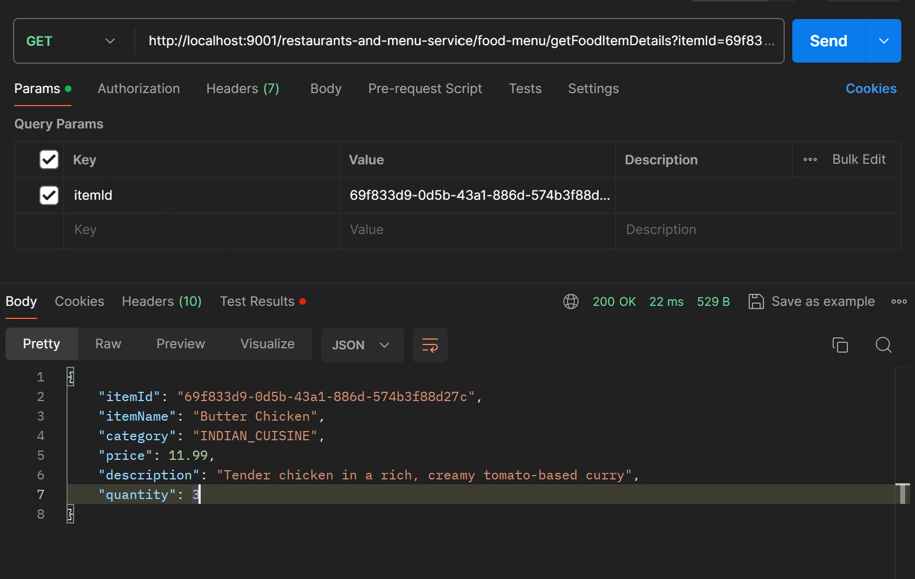

**Get Restaurant by itemId**

* Again,this Api mainly serves the internal purpose and used during communication with delivery service to restaurant details by item Id to know which restaurant the item belongs to.

Method Type : GET

Request Param : itemId

Request URL : food-menu/getRestaurantByItemId

Response :

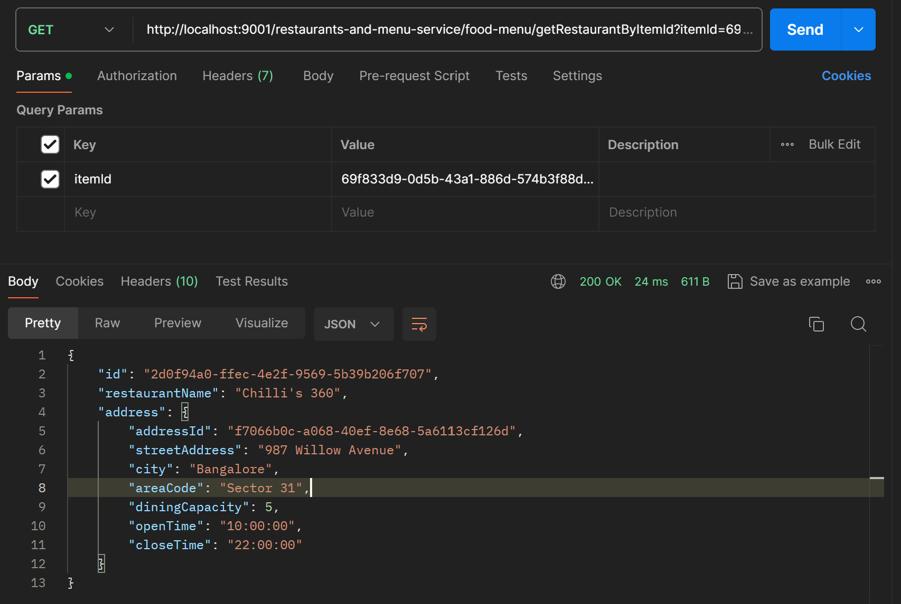

3.DELIVERY-SERVICE

Add Item to the Cart

* The purpose of this API is to add the item to the cart according to the itemId and the quantity provided in the request body by the user and update the quantity in the inventory as well.
* It validates the quantity in the inventory as per the user input and provides response accordingly.
* Also,this API interacts with restaurants-and-menu-service to update the quantity of the item since the input item quantity is reserved for the user at this step.

Method Type : POST

Request Body :

{

    "itemId":" b7514fa4-ce5d-4f38-a0bc-ded1c9c66f9d",

    "quantity":2

}

Request URL : food-delivery/addItemToTheCart

Response :

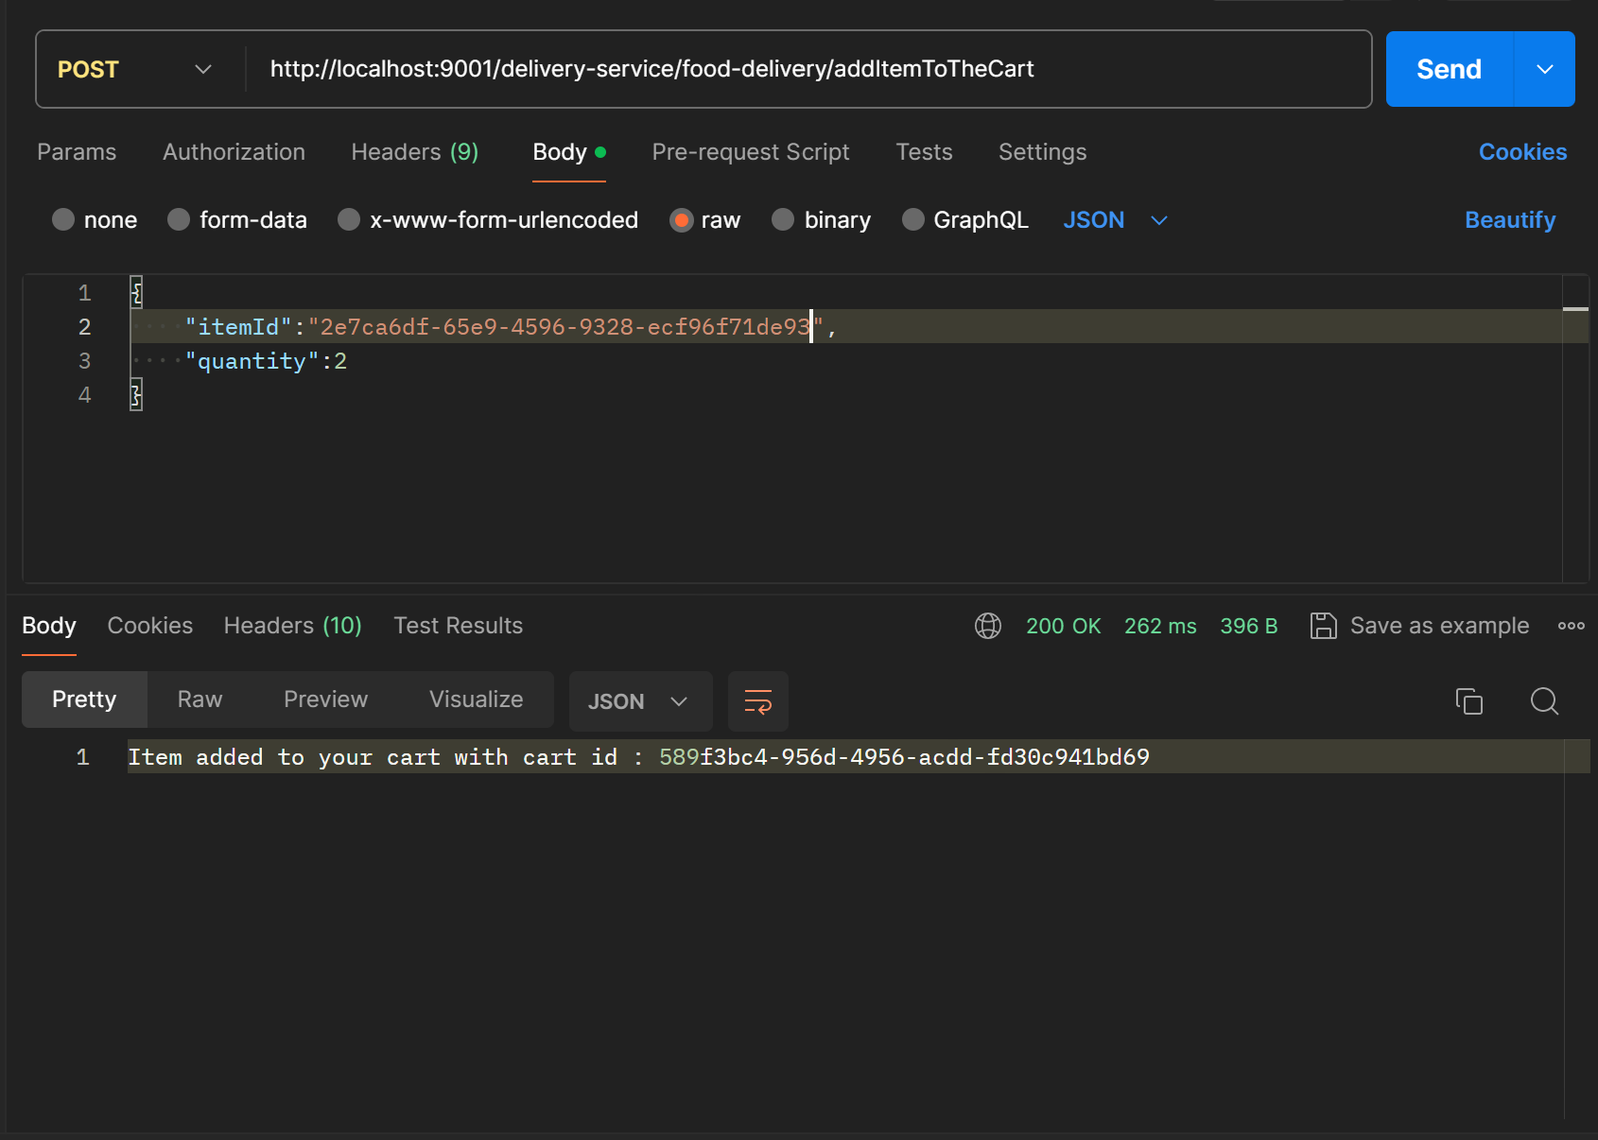

**Remove Item from the cart**

* Through this API,user can remove the added items from the cart with the help of itemId.

Though, during removal ,the item will be removed from cart completely unlike while adding where quantity is provided. Here, the item completely will get removed.

Method Type : POST

Request Param : itemId

Request URL : food-delivery/removeItemFromTheCart

Response:

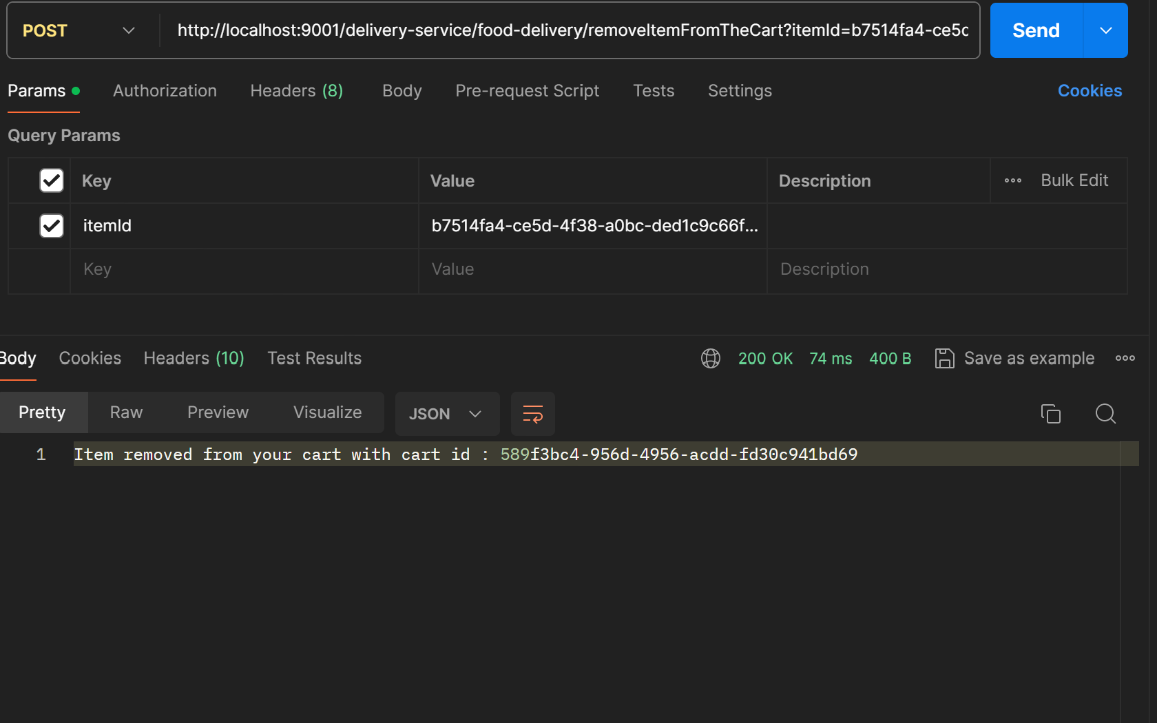

**View Items in the cart**

* This Api is used to view the items present in the user’s cart. If nothing is present in the   
  cart, response will be shown accordingly.
* The response includes the list of food items present in the cart as well as the number of items and total price of the items .

Method Type : GET

Request URL : food-delivery/viewItemInTheCart

Response:

{

    "numberOfItems": "2",

    "totalPrice": "23.98",

    "cartDataList": [

        {

            "itemId": "b7514fa4-ce5d-4f38-a0bc-ded1c9c66f9d",

            "itemName": "Butter Chicken",

            "restaurantDetails": {

                "restaurantName": "Chilli's 360",

                "address": {

                    "addressId": "6eb6924a-f988-4a76-9e71-44f0b67b95a4",

                    "streetAddress": "987 Willow Avenue",

                    "city": "Bangalore",

                    "areaCode": "Sector 31"

                }

            },

            "quantity": 2,

            "orderStatus": "PENDING",

            "price": 11.99

        }

    ]

}

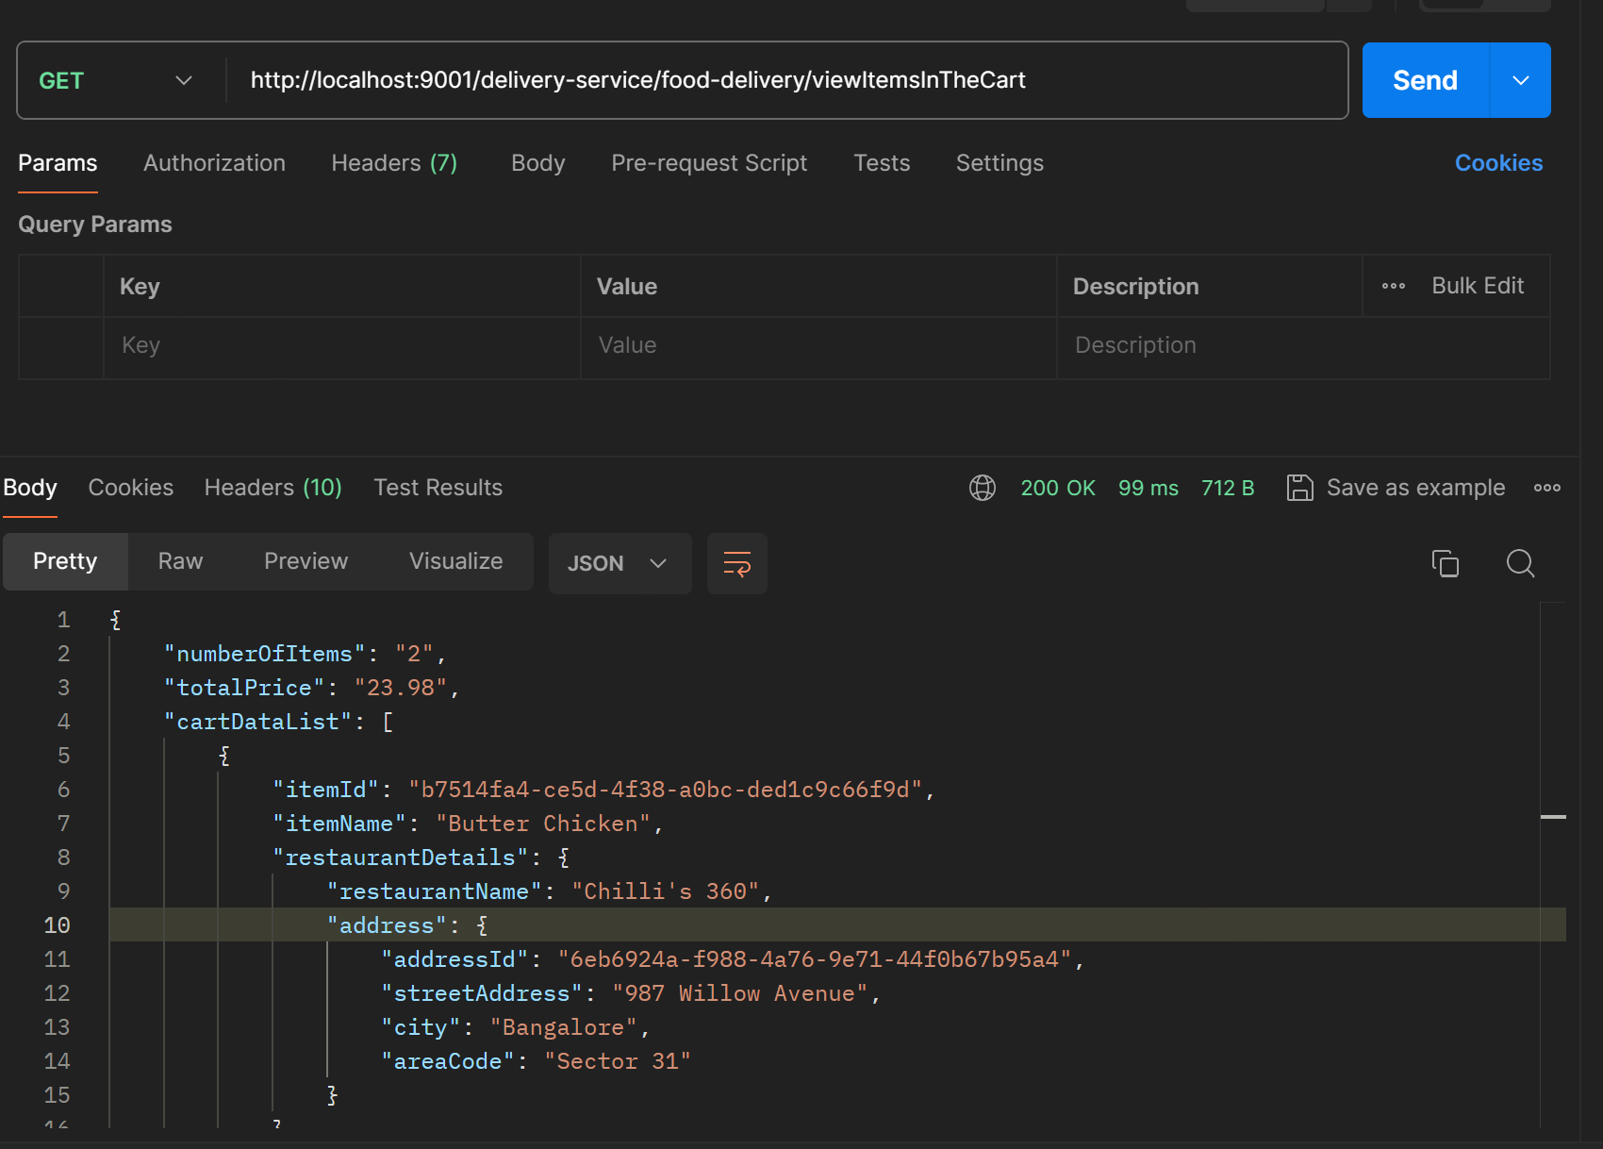

**Confirm Order**

* This API serves the purpose of placing the order .
* Input includes the user’s address details , contact number .  
  The items present in the cart are moved for the purpose of order placement.
* This API interacts with the payment -service as well where the payment is processed.
* Once the payment is processed and the success response is received from the payment-service , the order is placed and the order details are sent to the user.

The order details are sent to the restaurant as well by interacting with the restaurants-and-menu-service.

Method Type : POST

Request URL : food-delivery/confirmOrder

Request Body :

{

    "streetAddress":"B-Street",

    "city":"New Delhi",

    "areaCode":"Sector 55",

    "contactNo":"8178808221"

}

Response:

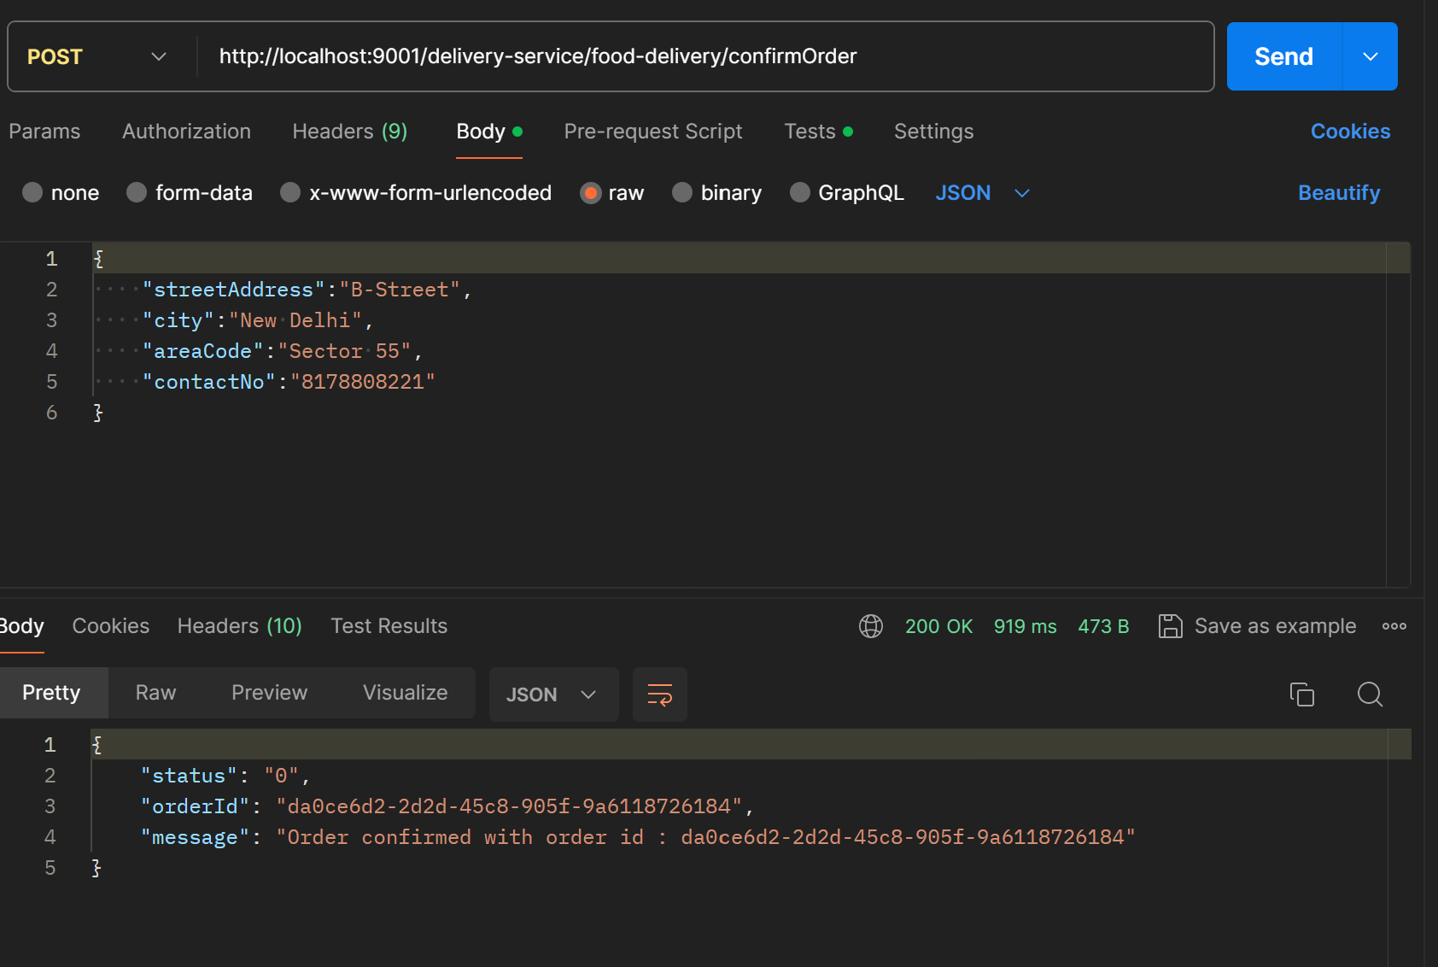



Below are the order details logged in delivery-service which are sent to the customer.

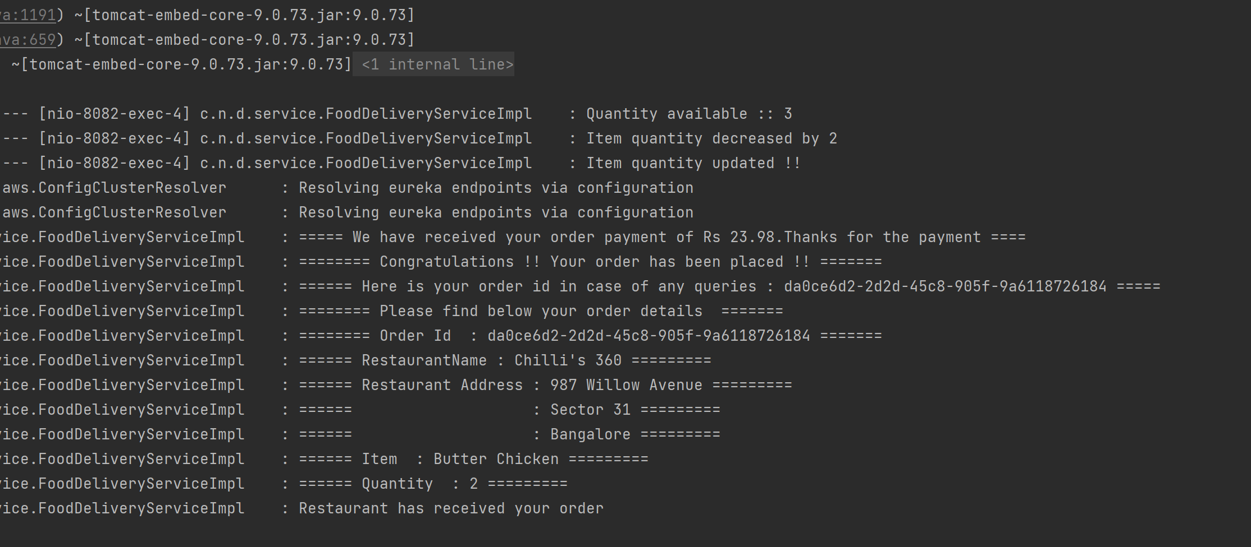

These details are sent to the restaurants-and-menu-service as well where the restaurant receive information about the order.

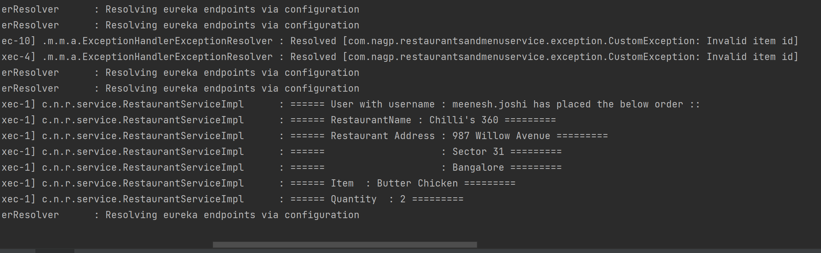

In this way,the notifications are being sent to both the restaurant and the customer through this service once the order is confirmed.

* Cancel the order.

This API is used by user to cancel the order if required.

It accepts an orderId as input.

It interacts with the payment-service to call the processRefund api for the refund processing.

Method Type : POST

Request URL : food-delivery/cancelOrder

Request Param : orderId

Response:

{

    "status": "0",

    "orderId": "eaf4ec04-44b9-4e86-b489-e42a193a2af3",

    "message": "Your order with order id : eaf4ec04-44b9-4e86-b489-e42a193a2af3 is cancelled now.You will get your refund of Rs 11.99 soon"

}

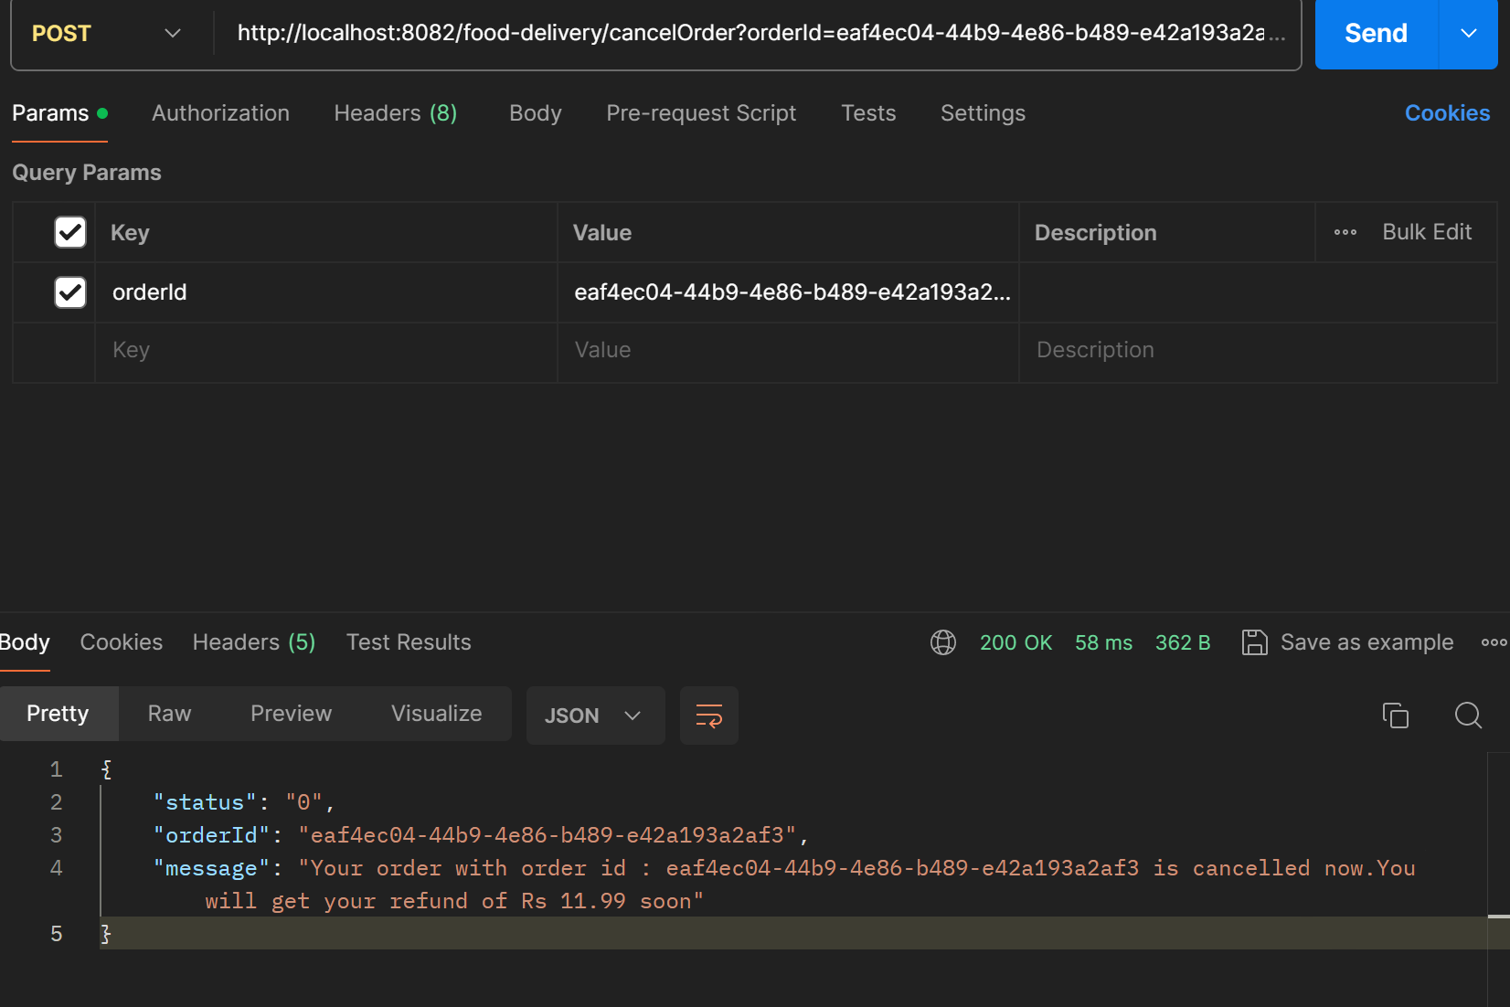

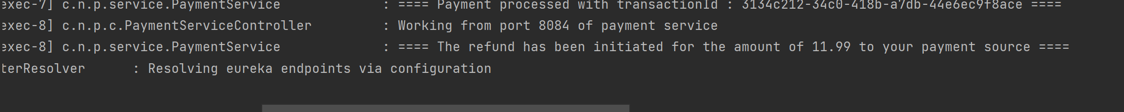

4.DINING-SERVICE

* Book Dining
* With the help of this API, user can book a dining for a particular date on particular time slot.
* Validations are placed with respect to the slot timings and the dining capacity of the restaurant.
* If the dining capacity is exceeded for a particular time slot on a given date for the restaurant and the user tries to book for the same slot, the appropriate response is displayed.
* Once booking is confirmed, the notification for booking is sent to the user as well as the restaurant by interaction through restaurants-and-menu-service.

Method Type : POST

Request URL : /bookDining

Request Body :

{

    "restaurantId":" 7dc961a3-12b0-4942-b4f0-eb53216b492c",

    "date":"11-03-2024",

    "bookingSlot":{

        "startTime":"14:00",

        "endTime":"15:00"

    },

    "noOfGuests":4,

    "userEMail":"meenesh.joshi@gmail.com",

    "userContactNo":"8178808221"

}

Response:

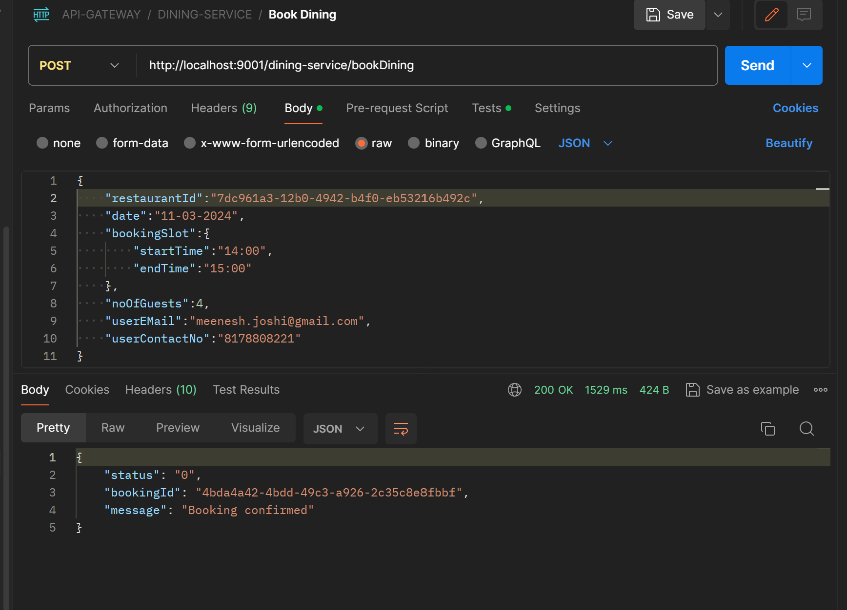

As you can see in the logs, notification is sent to the user regarding the booking details.

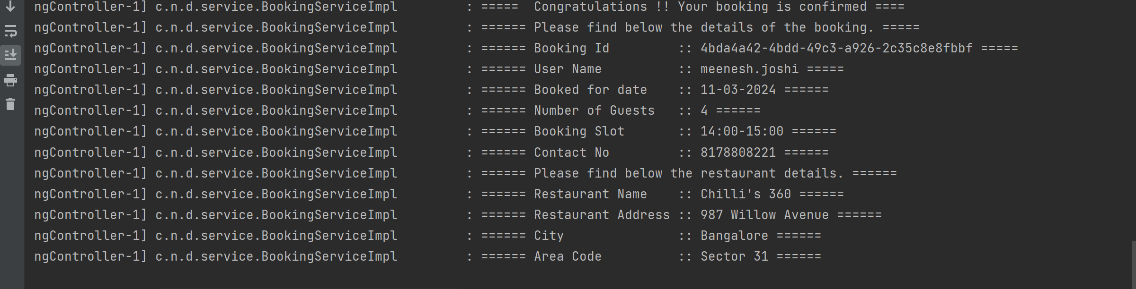

The restaurant is also notified by interaction through restaurants-and-menu-service.

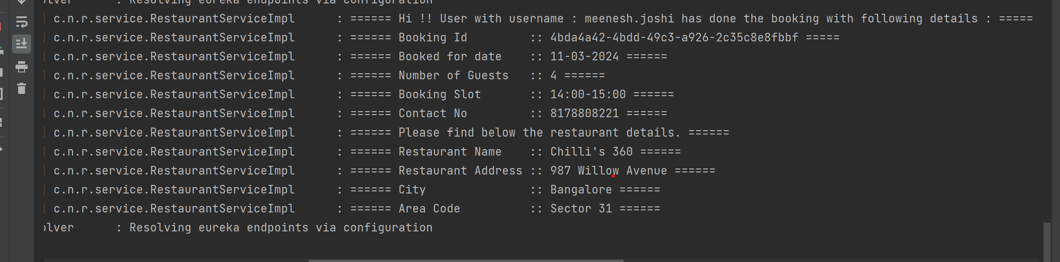

* View Bookings

This Api is used to view the dine bookings done by the user.

No params are required here.

Method Type : POST

Request URL : /viewBooking

Response:

[

    {

        "bookingId": "4bda4a42-4bdd-49c3-a926-2c35c8e8fbbf",

        "restaurant": {

            "restaurantId": "7dc961a3-12b0-4942-b4f0-eb53216b492c",

            "restaurantName": "Chilli's 360",

            "address": {

                "streetAddress": "987 Willow Avenue",

                "city": "Bangalore",

                "areaCode": "Sector 31",

                "diningCapacity": 5,

                "openTime": "10:00:00",

                "closeTime": "22:00:00"

            }

        },

        "date": "11-03-2024",

        "startTime": "14:00:00",

        "endTime": "15:00:00",

        "bookingStatus": "CONFIRMED",

        "bookedOn": "10-March-2024 20:09:35",

        "noOfGuests": 4

    }

]

* Cancel Booking

This API is used by user when he needs to cancel a particular dine booking.

It takes a bookingId as input and proceeds to cancel the booking.

Request Param : bookingId

Response:

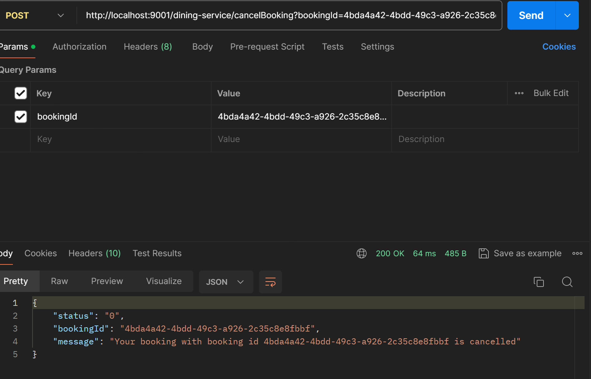

5.PAYMENT-SERVICE

This service is not directly exposed to the user. It is used by the delivery-service for the processing of payment during order confirmation and the refund process during order cancellation.

* Make Payment

As the name suggests, this service is for payment processing .

It takes card details and amount as input.

Method Type: POST

Request URL : /makePayment

Request Body:

{

    "cardNumber":"1231231231231231",

    "cvv":"123",

    "amount":"450"

}

Response :

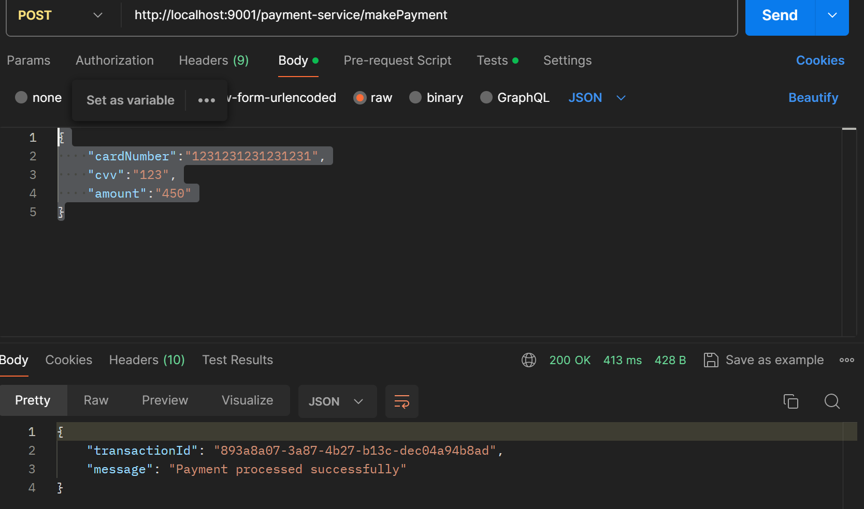

* Process Refund

This API is for processing of refund.

It takes transaction id as input.

Method Type: POST

Request URL : /refund

Request Body :

{

    "transactionId":"b196b343-ace1-4f81-8563-70afd125b058"

}

Response :

{

    "transactionId": "b196b343-ace1-4f81-8563-70afd125b058",

    "message": "Refund processed successfully"

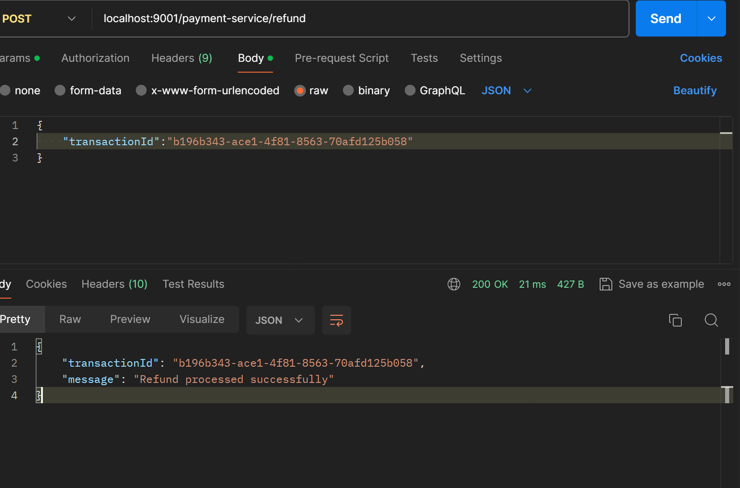

Food-Delivery:

Success flow:

Signup - > Login -> Search Menu -> Add Item to the cart -> Confirm Order

Here, the user will signup to the portal through user-service and will then login using his credentials. Once the user is logged in , he can search for restaurants and food items and their availability through the restaurants-and-menu-service.

Then the user can add to cart the desired food item and quantity required through the delivery-service and the item will be added to the user’s cart and here the restaurants-and-menu-service will be called internally which will interact with the inventory and that quantity will be blocked for other users.

After this, the user can proceed to confirm order where he can provide the delivery address and the contact details and the items present in the cart will be placed for food-delivery and the payment-service will be called internally and returns the response after all the validation.

Also,to add here,we can implement a scheduler for the add cart service where if the item is present in the cart for more than a particular duration, it should be unblocked for other users.

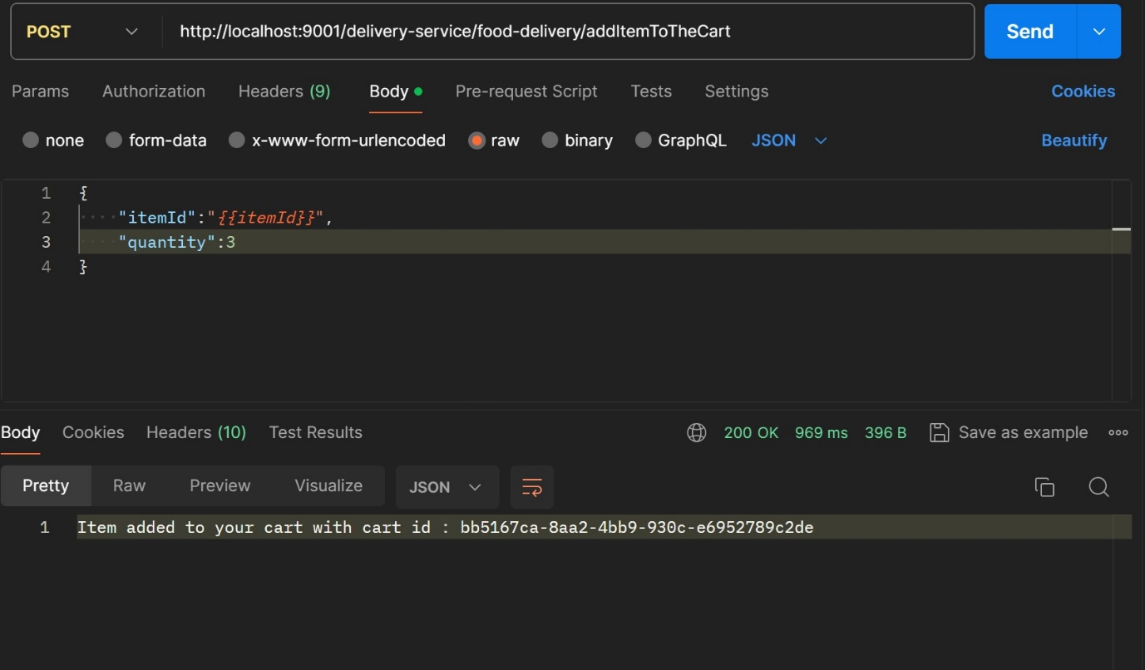

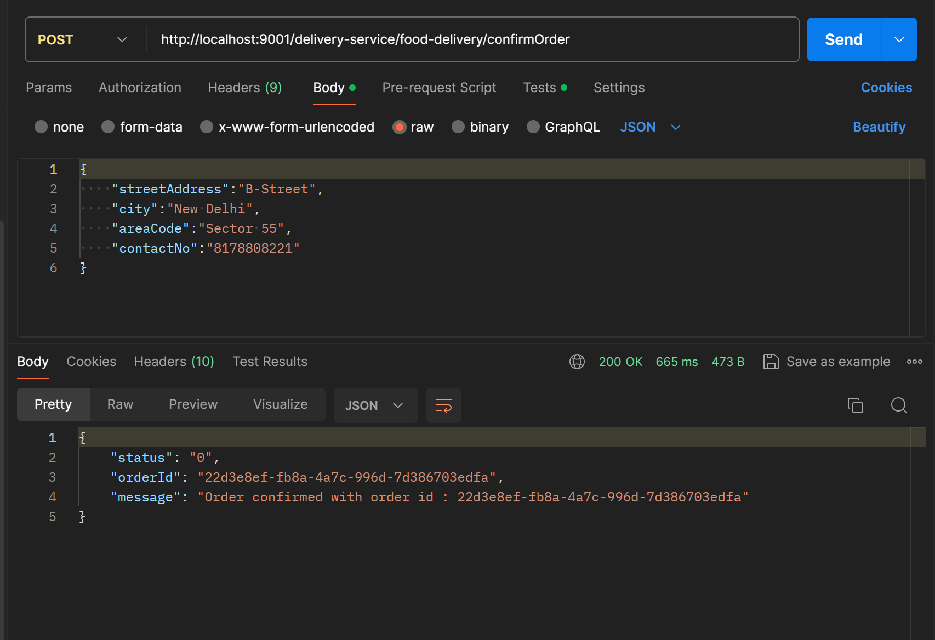

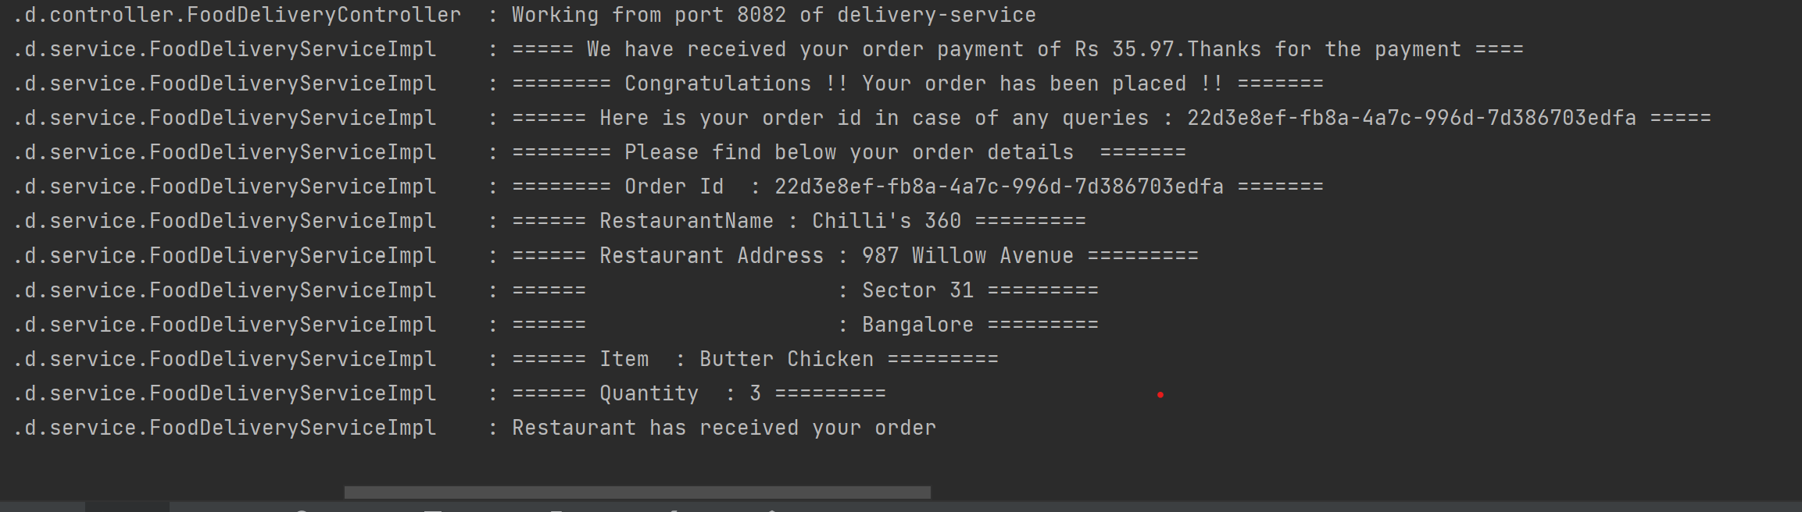

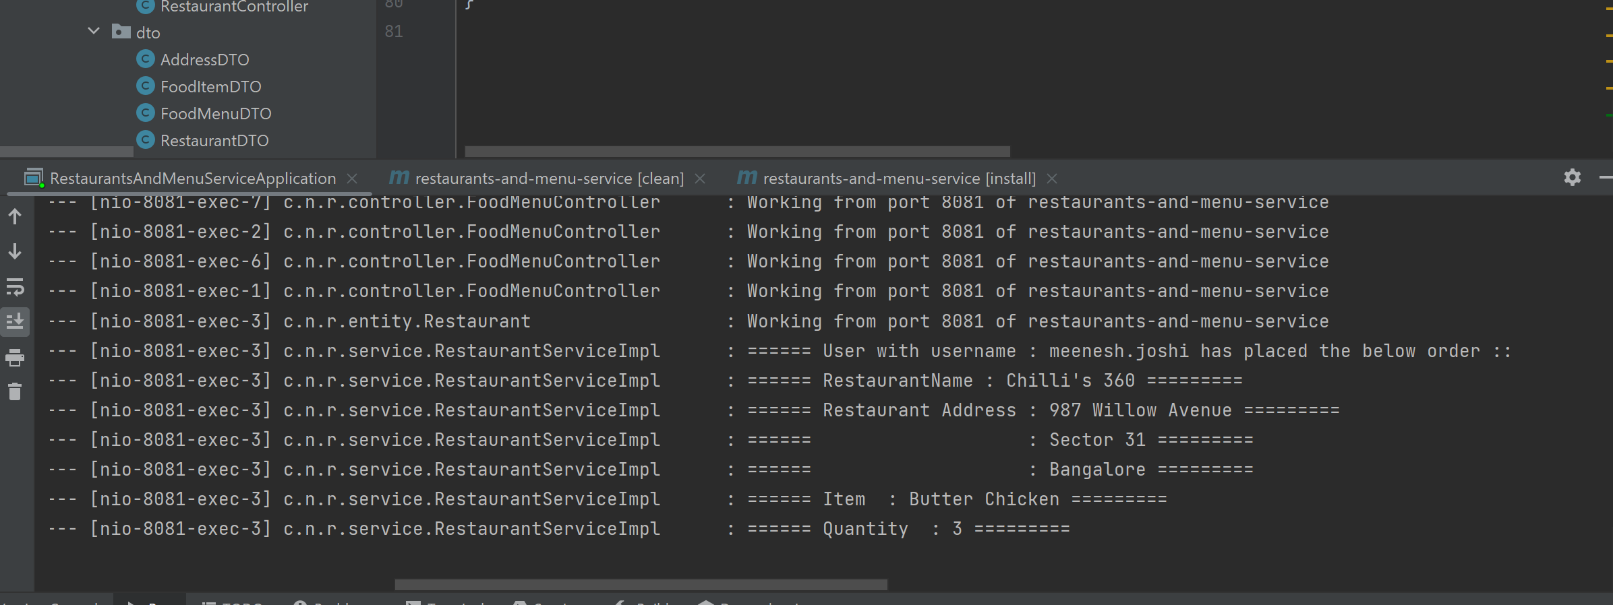

Failure Order Flow:

Signup -> Login -> Search Menu -> Add Items -> Confirm Order

**Failure scenario 1: Payment Service is down.**

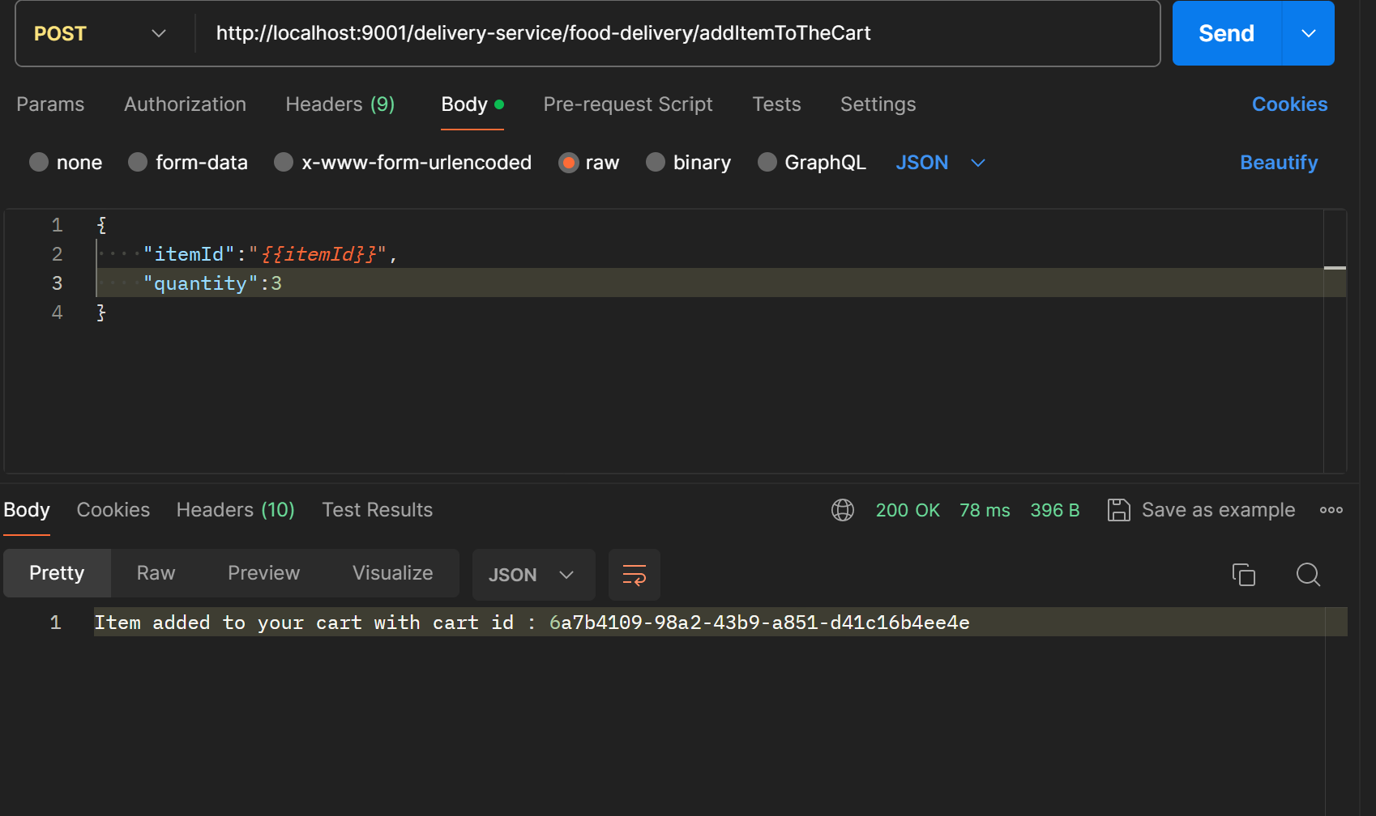

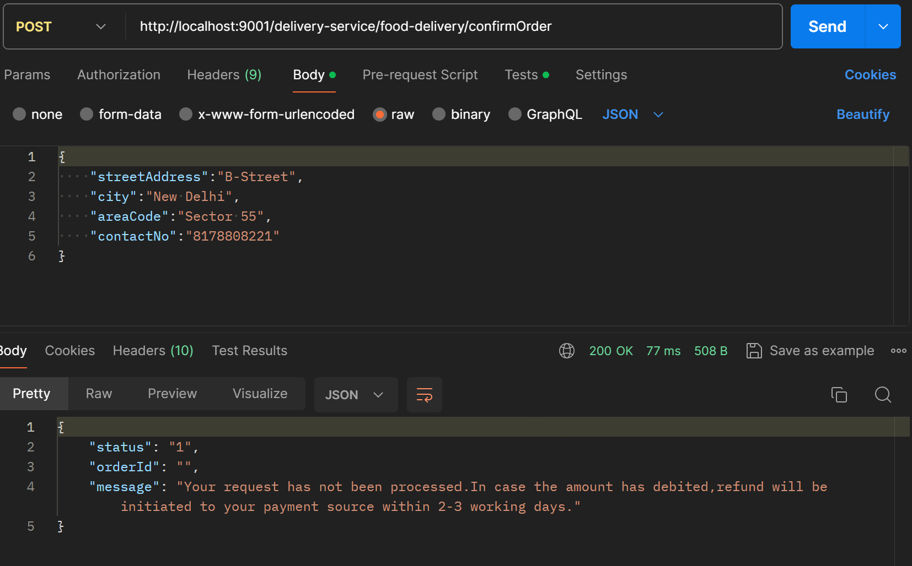

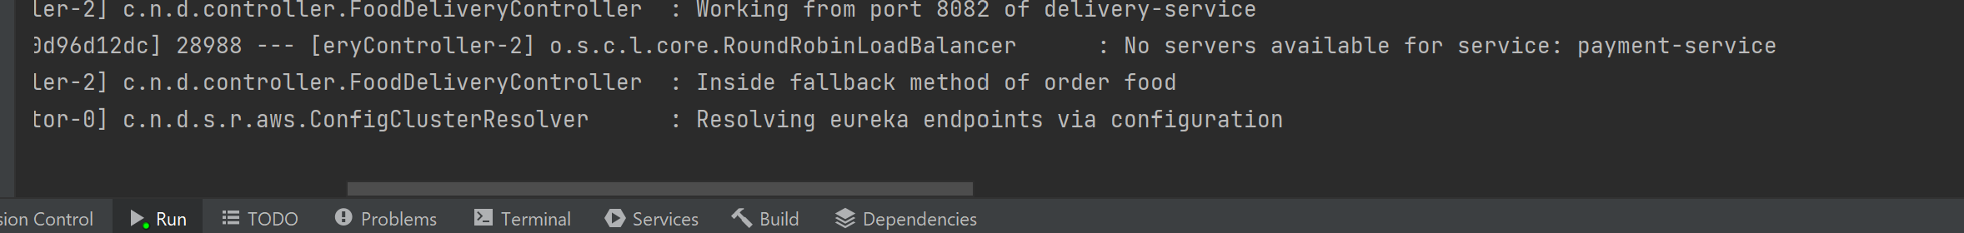

So, if the payment service is down, then the payment is not able to complete so the flow will go to the confim order fallback method and the response will be shown accordingly.

**Failure Scenario 2 : If the restaurants-and-menu-service goes down**

This service is used by the delivery-service for fetching the item and restaurant details according to user input so again the fallback method of the delivery-service will be called.

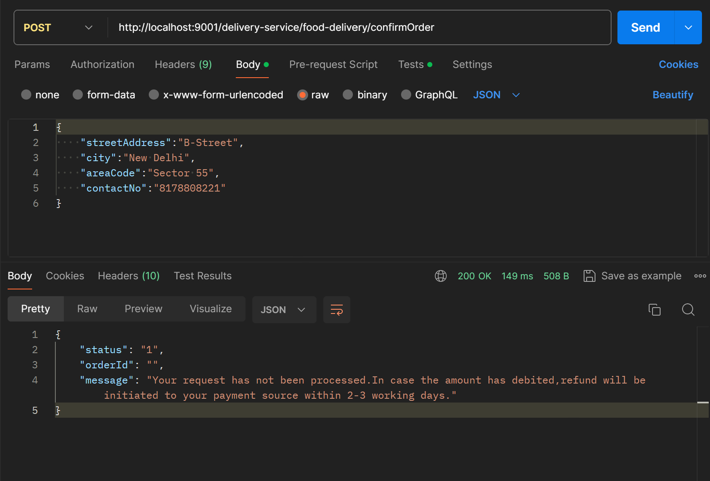

**Failure scenario 3: If the payment-service is up , but the session timeout happens**

So, if the user has confirmed the order and the order has been placed and the payment-service called internally does payment processing and in between a session timeout happens, the cancel order service should be called and user would be issued a refund if the payment as been processed already

This would be one such scenario but I didn’t knew how to achieve this on my local system, but worth mentioning here I feel.

Dine-Booking:

Success flow :

**Signup -> Login -> Book Dining**

In this user will first create his account using user service then user will login to his account using his credentials then search for the restaurant using restaurants-and-menu-service .

Through the dining booking service,user can book dining for a particular slot in and for a particular restaurant with other details like providing the no of guests and slot time.This service calls restaurants-and-menu service internally to get the diningCapacity of the particular restaurant and checks the availability on the particular slot.

If the slot is available, the booking is confirmed.

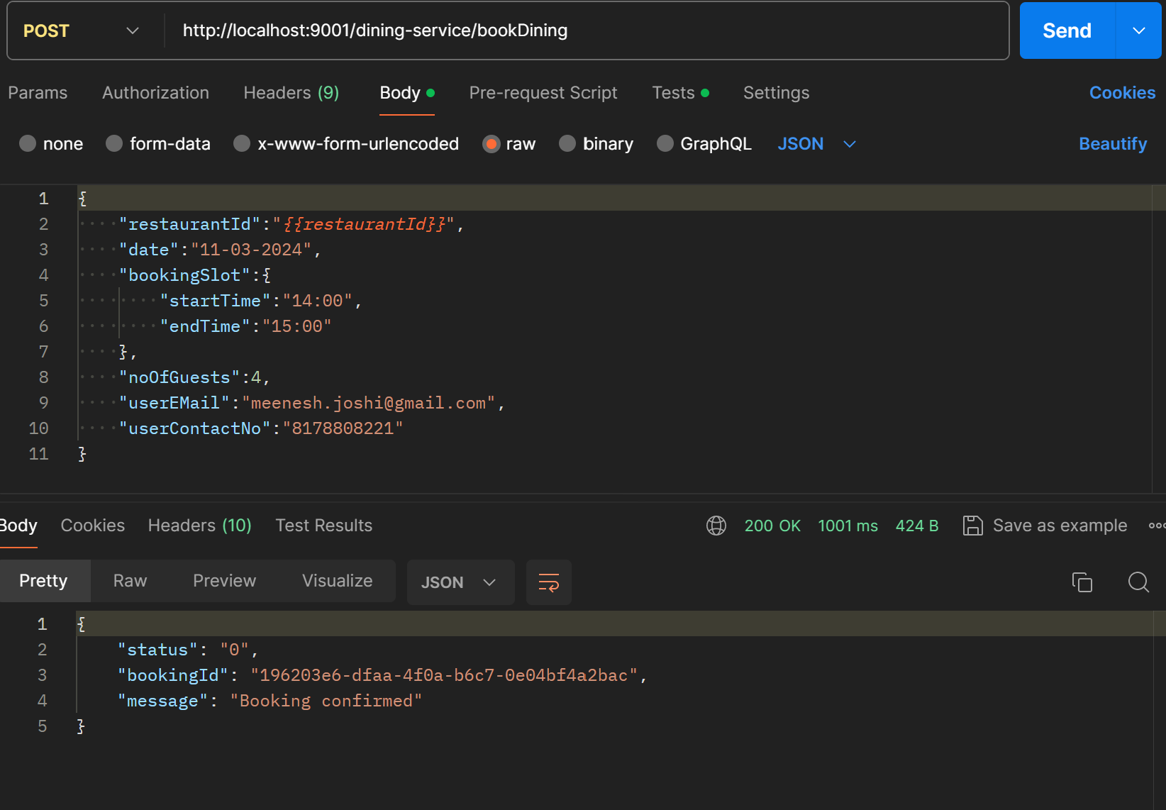

Failure Flow:

**Scenario 1 .If the restaurants-and-menu-service goes down**

Since the service communicates with the restaurants-and-menu service to check the dining capacity of the restaurant,if it goes down, the fall back method of dine booking will be called and response will be shown accordingly.

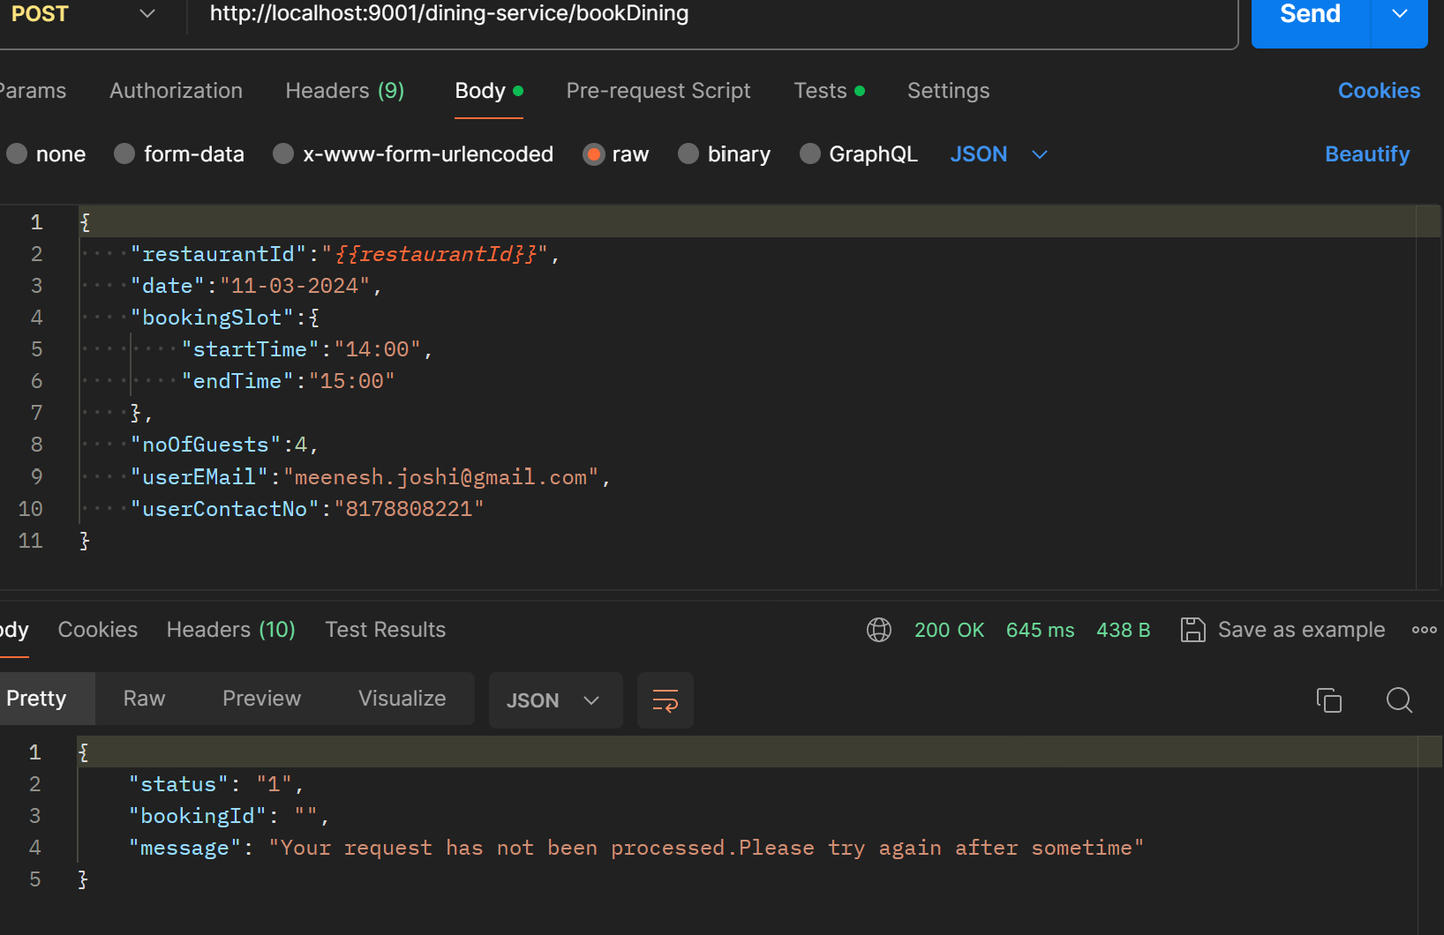



**Scenario 2: Restaurants-and-menu-service is up, the dining capacity is full**

**I**n this scenario,restaurants-and-menu-service is up but the dining capacity for that particular slot is already exhausted or dining capacity left is less than the no of guests user wants to do the booking for, in such case the response will be shown to user accordingly.

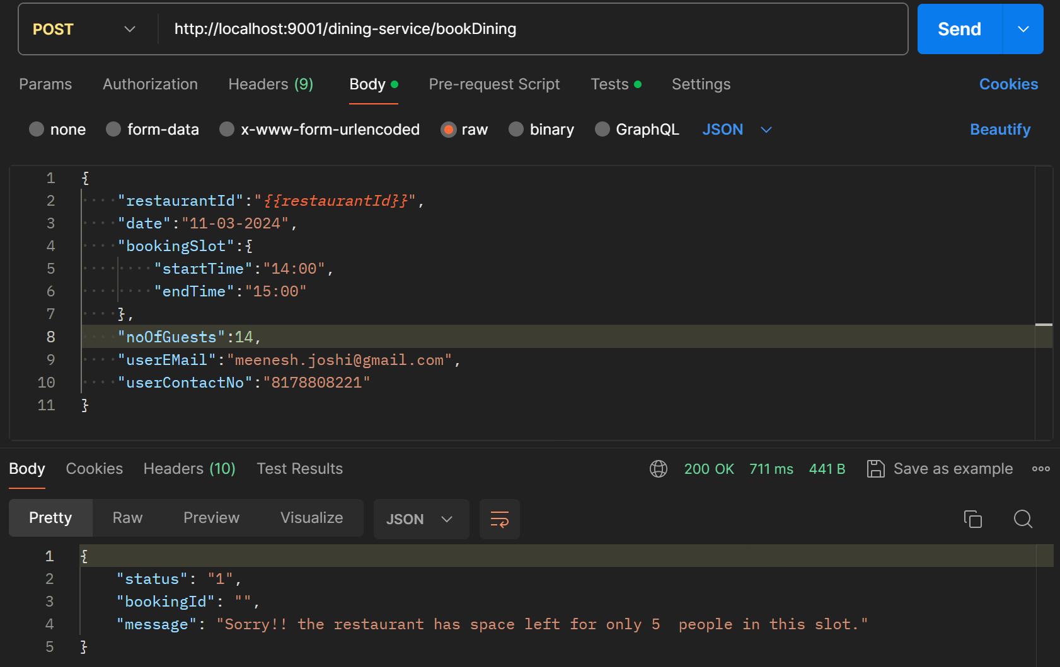

**Discovery Server:**

All the services are registered on the eureka server running on port 8761.

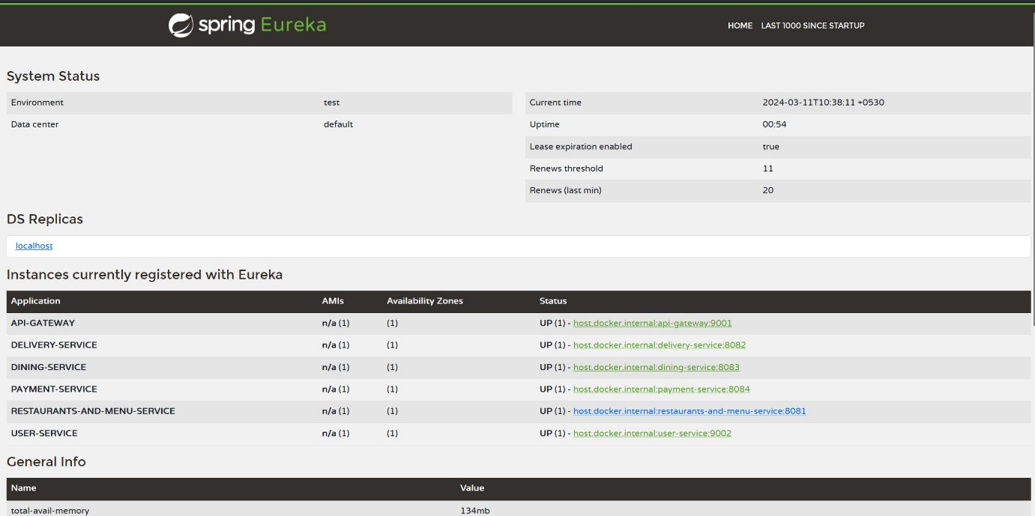

**Inter-communication approach:**

* The interactions between various microservices is happening using Rest Template and Web Client where the necessary URL and associated details are fetched using the discovery server.
* The API Gateway microservice sits between the user/postman and the microservices for load balancing and to keep the paths dynamic, we have added a discovery-server 'name of service', to which all the discovery clients registers as soon as they boot up.
* From client-server perspective, the first interaction is between the API gateway and the user-service for signup and login.
* For all the subsequent requests, The API gateway authenticates and authorize using the token and role respectively.
* The delivery-service and dining-service interact with restaurants-and-menu-service (for all the inventory related details and updates) and the payment-service for the payment related functionalities.

**Cross-cutting-concerns:**

* Slf4J logger is being used for logging in all microservices.
* For notifications for delivery and dining service while order confirm and din booking, logging is being done both on for user for order/booking details and as well as to send user and order/booking details to restaurant.
* Circuit breaker pattern is implemented using Hysterix for both delivery and dining services so like if any of the internal service is down , the request is sent to its fallback method and return the response instead of throwing the error.

**Deployment:**

Docker images were built using the below command replacing the <service-name> with each service name .

**docker build -t meeneshjoshi/<service-name>:latest .**

These images were then pushed to docker hub using the below command:

**docker push meeneshjoshi/<service-name>:latest**

**Docker images :**

* meeneshjoshi/restaurants-and-menu-service:latest
* meeneshjoshi/discovery-server:latest
* meeneshjoshi/api-gateway:latest
* meeneshjoshi/user-service:latest
* meeneshjoshi/delivery-service:latest
* meeneshjoshi/dining-service:latest
* meeneshjoshi/payment-service:latest

For deployment purpose,a docker compose is placed inside the deployment folder and you can run all the containers using a simple command:

**docker compose up**

**Overlapping issues:**

* Overlapping issues in delivery -service is handled by reserving the items while adding the cart for the particular user and allocating the items one by one by checking whether they are available or not.
* For security, we are using token verification in user-service with the help of api-gateway.
* Postman collection is attached inside all the repos as well as the deployment folder in which all the services are behind the gateway and user can interact with other services only after login through the user service.
* For notification loggers are implemented in each of the services for all the required details.

**Use cases:**

* Cancellation functionality is also given for both delivery and dining services.
* For restaurant owners also the functionality of ‘Add Restaurant’ and ‘Add Food Item to the menu’ is also given inside the restaurants-and-menu-service.
* For dining service, slot availability is being checked for that particular time slot the user is asking for. Users can also view the bookings later on once the booking is done and even cancel them.
* For delivery service, user can add items from more than one restaurant in the cart provided the availability. Also, before placing the order, user can use “viewItemsInTheCart” service to view items in the cart.

**Technologies and tools used:**

Technologies Used:-

* Java – 11
* Spring Boot
* Docker
* Maven

Tools: -

* IntelliJ Idea
* Docker Desktop
* Postman